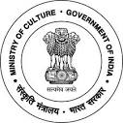

National Council of Science Museums
Ministry of Culture, Govt. of India
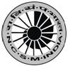

33, Block-GN, Sector- V, Salt Lake
Kolkata- 700091
Telephone- 033-2357-5545/9347/0850
www.ncsm.gov.in
Notice Inviting e-Tender Ref. No. I-15014/61

Online e-tender (Percentage Rate Bid) are invited from reputed and experienced civil contractors capable of carrying out the work of “Science Park & allied development works of Sub-Regional Science Centre at Bargarh, Odisha’’ with excellent finishing quality at an estimated cost of Rs. 69,85,662.00 The work consists of RCC road, pathways, parking, rain water harvesting etc.
For online submission & details, visit to website http://eprocure.gov.in/eprocure/app and Search with
Tender Id: 2017_NCSM_234916_1
Also visit website www.ncsm.gov.in for details.

