
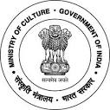
National Council of Science Museums
Ministry of Culture, Govt. of India
33, Block-GN, Sector- V, Salt Lake
Kolkata- 700091
Telephone- 033-2357-5545/9347/0850

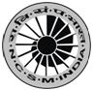
www.ncsm.gov.in
Notice Inviting E-Tender No. I-15014/61/Electrical/DG Set

E-Tender is invited for the work of “Supply, Installation, Testing & Commissioning of 125 KVA Silent Gen-set at Sub Regional Science Centre, Bargarh, Odisha at an estimated cost of `13.96 Lakh. Please visit website http://eprocure.gov.in/eprocure/app and search with Tender Id: 2017_NCSM_235317_1 for details & online tendering. Tenders may be submitted between 21.08.2017 and 13.09.2017.

