NATIONAL COUNCIL OF SCIENCE MUSEUMS
SECTOR-V, BLOCK-GN, BIDHANNAGAR,
KOLKATA : 700 091.

NOTICE INVITING E-TENDER

TENDER No. : I-18013/2/17(123).

On-line digitally signed e-tenders are invited from reputed manufacturers for Supply, Installation, Testing & Commissioning of “Granite Ball Ellipse Fountain” as per Council’s drawings and specifications. Vendors having proven experience and capability of executing the order at a time may download the Tender Papers from Central Public Procurement Portal (CPPP): http://eprocure.gov.in/eprocure/app or from Council’s website www.ncsm.gov.in as per the following schedule:-

Published Date | September 06, 2017
Bid Document Download Start Date | September 06, 2017
Bid Document Download End Date | September 23,2017
Bid Submission Start Date | September 06, 2017
Bid Submission End Date | September 25, 2017 (upto 12 p.m.)
Technical Bid opening date | September 26, 2017 (at 12 p.m.)
Financial Bid opening date | October 03, 2017 (at 3:00 p.m.)
Earnest Money | INR 1,00,000 (Rupees One Lakh only)

The on-line bid along with the Earnest Money Deposit of INR 1,00,000 in the form of scanned copy of the Demand Draft/Pay Order should be uploaded by the due date and time as per the above schedule. No tender will be accepted without requisite EMD. The original EMD in the form of Demand Draft/Pay Order shall be submitted by the bidder to this office either before or at the time of tender opening. The on-line bids will be opened on the scheduled date and time prescribed above. Bidders may be present during opening of tenders, if so desire. Off-line tenders shall not be accepted and no request in this regard will be entertained whatsoever. NCSM reserves the right to accept or reject any or all tenders in full or in part without assigning any reason whatsoever.

General Information and Instructions

- The instruction given herein will be strictly binding on the tenderers and deviation, if any will make the tender or tenders liable to be considered invalid. Tenders incorporating additional conditions by the tenderer are liable for rejection.

- Before submitting the tender, the tenderers shall examine carefully the technical specifications for supply, testing, installation & commissioning of Rotating Granite Ball Ellipse fountain as per the Technical specifications enclosed with the tender of the National Council of Science Museums, Kolkata.

- Bids shall be submitted online only at CPPP website: https://eprocure.gov.in/eprocure/app Manual bids shall not be accepted.

- The instruction given in “Annexure-A” for “Instruction for Online Bid Submission” should be strictly followed during submission of the Bid.

- Bid documents may be scanned with 100 dpi with black and white option which helps in reducing size of the scanned document.

- Bid should be submitted along with the Earnest Money of Rs. 1,00,000/- (Rupees One Lakh only) by way of crossed Demand Draft/Pay Order on any nationalized bank of India payable in favour of “NATIONAL COUNCIL OF SCIENCE MUSEUMS, KOLKATA”. Earnest Money deposit in the form of Bank Guarantee bond or any other bond shall not be accepted and shall be rejected straightway. Earnest Money deposits in respect of such offers which are not accepted will be returned to the Bidders within 30 working days from the date on which the final decision is taken about the source from which the items under tender are to be procured or within 2 (two) months from the date of the opening of the tenders, whichever is earlier. Earnest Money deposit in respect of the successful bidders will be retained with the Council until entire execution of the order as per terms of the tender. If the successful bidder fails to execute the order strictly as per the Council’s drawing & specification in full or part within the stipulated delivery period of the purchase order, the Earnest Money deposit retained with the Council shall be forfeited forthwith after cancellation of the concerned order. No interest will be paid on the Earnest Money deposited with the Council.

- Validity of Bids: The Bids should remain valid for 180 days from the date of bid opening.

- Rejection of Bids: Canvassing by the Bidder in any form, unsolicited letter and post-tender correction may invoke summary rejection. Conditional tenders will be rejected. Non-compliance of applicable General Information and Instruction will disqualify the Bid.

- The tenderers should have Digital Signature Certificate (DSC) for filling up the Bids. The
Person signing the tender documents should be authorized for submitting the on line e-
tender.
- The Financial Bid (BOQ) shall be filled in and signed by the authorized signatory online as per Proforma “Annexure-E” available at Central Public Procurement Portal e-tender system website http://eprocure.gov.in/eprocure/app. Off line Financial Bid shall not be accepted.

- Tender must be uploaded in two separate covers marked Cover-1 and Cover-2. The contents of Cover-1 and Cover-2 will be as follows:-

Cover-1

- Scanned copy of General Terms & Conditions as detailed in Annexure-B duly signed by the
authorised signatory with official stamp as a token of acceptance of the Terms &
Conditions.

- Copy of the current and valid Trade License and Dealership Certificate, as applicable, duly
signed by the authorised signatory with official stamp.

- Scanned Copy of the current and valid GST Registration Certificate indicating GST number
duly signed by the authorized signatory with official stamp. (Please note that Provisional GST Registration Certificate is also acceptable for the time being)

- The scanned copy of the Demand Draft/Pay Order for Rs.1,00,000/- (Rupees One Lakh
only) as Earnest Money Deposit .

- The ‘Declaration’ of the bidder( as detailed in Annexure-C)duly signed by the authorized
signatory with official stamp.

- Technical(Techno-Commerical) bid as per “Annexure-D” format duly filled in and signed by the authorised signatory with official stamp.

- Scanned copies of the Council’s ‘Drawings & Technical Specification’(as detailed in Annexure-F) duly signed by the authorized signatory with official stamp as a token of acceptance for supply &
installation of materials in accordance to the same.

Cover-2
The Financial Bid ( as per Annexure-E format) i.e. Schedule of Price Bid in the form of attached BOQ Proforma shall be duly filled in, digitally signed and uploaded online by the bidder.

The Cover-1, i.e. Technical (Techno-Commercial)Bid shall be opened by the Council at the first instance and evaluated by the competent authority of the Council. At the second stage, the Cover-2 containing Financial Bid of only techno-commercially acceptable offers shall be opened for further evaluation and ranking before awarding the contract.

- The authorities of National Council of Science Museums, who does not bind themselves to
accept the lowest tender, reserves the right to reject or accept any or all tenders wholly or partially without assigning and reason whatsoever.

ANNEXURE -A
NATIONAL COUNCIL OF SCIENCE MUSEUMS
SECTOR-V, BLOCK-GN, BIDHANNAGAR,
KOLKATA – 700 091.

TENDER No.: I-18013/2/17(123)

Instructions for Online Bid Submission
- The bidders are required to submit soft copies of their bids electronically on the CPP Portal, using valid Digital Signature Certificates. The instructions given below are meant to assist the bidders in registering on the CPP Portal, prepare their bids in accordance with the requirements and submitting their bids online on the CPP Portal.
- More information useful for submitting online bids on the CPP Portal may be obtained
at https://eprocure.gov.in/eprocure/app

REGISTRATION
  - Bidders are required to enroll on the e-Procurement module of the Central Public Procurement Portal (URL: https://eprocure.gov.in/eprocure/app ) by clicking on the link “Online bidder Enrollment” on the CPP Portal which is free of charge.
  - As part of the enrolment process, the bidders will be required to choose a unique username and assign a password for their accounts.
  - Bidders are advised to register their valid email address and mobile numbers as part of the registration process. These would be used for any communication from the CPP Portal.
  - Upon enrolment, the bidders will be required to register their valid Digital Signature Certificate (Class II or Class III Certificates with signing key usage) issued by any Certifying Authority recognized by CCA India (e.g. Sify / nCode / eMudhra etc.), with their profile.
  - Only one valid DSC should be registered by a bidder. Please note that the bidders are responsible to ensure that they do not lend their DSC’s to others which may lead to misuse.
  - Bidder then logs in to the site through the secured log-in by entering their user ID / password and the password of the DSC / e-Token.
SEARCHING FOR TENDER DOCUMENTS
  - There are various search options built in the CPP Portal, to facilitate bidders to search active tenders by several parameters. These parameters could include Tender ID, Organization Name, Location, Date, Value, etc. There is also an option of advanced search for tenders, wherein the bidders may combine a number of search parameters such as Organization Name, Form of Contract, Location, Date, Other keywords etc. to search for a tender published on the CPP Portal.
  - Once the bidders have selected the tenders they are interested in, they may download the required documents / tender schedules. These tenders can be moved to the respective ‘My Tenders’ folder. This would enable the CPP Portal to intimate the bidders through SMS / e-mail in case there is any corrigendum issued to the tender document.
  - The bidder should make a note of the unique Tender ID assigned to each tender, in case they want to obtain any clarification / help from the Helpdesk.

PREPARATION OF BIDS
- Bidder should take into account any corrigendum published on the tender document before submitting their bids.
- Please go through the tender advertisement and the tender document carefully to understand the documents required to be submitted as part of the bid. Please note the number of covers in which the bid documents have to be submitted, the number of documents - including the names and content of each of the document that need to be submitted. Any deviations from these may lead to rejection of the bid.
- Bidder, in advance, should get ready the bid documents to be submitted as indicated in the tender document / schedule and generally, they can be in PDF / XLS / RAR / DWF/JPG formats. Bid documents may be scanned with 100 dpi with black and white option which helps in reducing size of the scanned document.
- To avoid the time and effort required in uploading the same set of standard documents which are required to be submitted as a part of every bid, a provision of uploading such standard documents (e.g. PAN card copy, annual reports, auditor certificates etc.) has been provided to the bidders. Bidders can use “My Space” or ‘’Other Important Documents’’ area available to them to upload such documents. These documents may be directly submitted from the “My Space” area while submitting a bid, and need not be uploaded again and again. This will lead to a reduction in the time required for bid submission process.
SUBMISSION OF BIDS
- Bidder should log into the site well in advance for bid submission so that they can upload the bid in time i.e. on or before the bid submission time. Bidder will be responsible for any delay due to other issues.
- The bidder has to digitally sign and upload the required bid documents one by one as indicated in the tender document.
- Bidder has to select the payment option as “offline” to pay the tender fee/EMD as applicable and enter detail of the instrument.
- Bidder should submit the EMD as per the instructions specified in the tender document. The original should be posted/couriered/given in person to the Tender Processing Section, latest by the last date of bid submission. The detail of the DD/any other accepted instrument, physically sent, should tally with the details available in the scanned copy and the data entered during bid submission time. Otherwise the uploaded bid will be rejected.
- A standard Price Schedule format (BOQ) has been provided with the tender document to be filled by all the bidders. Bidders are requested to note that they should necessarily submit their financial bids in the format provided and no other format is acceptable. If the price bid has been given as a standard BOQ format with the tender document, then the same is to be downloaded and to be filled by all the bidders. Bidders are required to download the BOQ file, open it and complete the unprotected cells with their respective financial quotes and other details. No other cells should be changed. In case no rate value is required to be quoted in any particular cell, that cell must be kept blank, figure ‘0’ (zero) shall not be entered in such cell(s). Once the details have been completed, the bidder should save it and submit it online, without changing the filename. If the BOQ file is found to be modified by the bidder, the bid will be rejected.

- The server time (which is displayed on the bidders’ dashboard) will be considered as the standard time for referencing the deadlines for submission of the bids by the bidders, opening of bids etc. The bidders should follow this time during bid submission.

- All the documents being submitted by the bidders would be encrypted using PKI encryption techniques to ensure the secrecy of the data. The data entered cannot be viewed by unauthorized persons until the time of bid opening. The confidentiality of the bids is maintained using the secured Socket Layer 128 bit encryption technology. Data storage encryption of sensitive fields is done. Any bid document that is uploaded to the server is subjected to symmetric encryption using a system generated symmetric key. Further this key is subjected to asymmetric encryption using buyers/bid openers public keys. Overall, the uploaded tender documents become readable only after the tender opening by the authorized bid openers.

- The uploaded tender documents become readable only after the tender opening by the authorized bid openers.
- Upon the successful and timely submission of bids (ie after Clicking “Freeze Bid Submission” in the portal), the portal will give a successful bid submission message & a bid summary will be displayed with the bid no. and the date & time of submission of the bid with all other relevant details.
- The bid summary has to be printed and kept as an acknowledgement of the submission of the bid. This acknowledgement may be used as an entry pass for any bid opening meetings.

ASSISTANCE TO BIDDERS
- Any enquiries relating to the tender document and the terms and conditions contained therein should be addressed to the Tender Inviting Authority for a tender or the relevant contact person indicated in the tender.

- Any queries relating to the process of online bid submission or queries relating to CPP Portal in general may be directed to the 24x7 CPP Portal helpdesk. The contact number for the helpdesk is 1800 233 7315.

*****************************

ANNEXURE-B

NATIONAL COUNCIL OF SCIENCE MUSEUMS
SECTOR-V, BLOCK-GN, BIDHANNAGAR,
KOLKATA: 700 091.

TENDER No. : I-18013/2/17(123).

GENERAL TERMS & CONDITIONS (GTC) FOR SUBMISSION OF TENDER FOR SUPPLY, INSTALLATION, TESTING & COMMISSIONING OF GRANITE BALL ELLIPSE FOUNTAIN STRICTLY AS PER COUNCIL’S DRAWINGS AND SPECIFICATIONS .

- Bidders should have necessary infrastructure and facilities so as to take up the job of supply of the tendered items strictly as per enclosed specifications and drawings with required financial capability.

- Price:
The prices and rates indicated/quoted shall be inclusive of cost of materials, supply, installation, testing & commissioning and all incidental charges to deliver the Granite Ball Ellipse Fountain at Manipur Science Centre, Imphal; Nagaland Science Centre, Dimapur; Shillong Science Centre, Shillong and Mizoram Science Centre, Aizwal . The rate of GST to be imposed on the rate shall be clearly mentioned. Prices and rate quoted shall be firm and fixed for the entire period of execution of the order and no escalation of rate on any ground whatsoever shall be applicable.

- The successful bidders shall submit the following documents within 7(Seven) days from the date of Placement of the order:-

- Duplicate copy of the order duly signed and stamped as a token of acceptance of the order.

- Time is the essence of this tender. The delivery shall be made strictly as per following:-

Stage-I
The tendered items including all its accessories as per given specifications & drawing shall be got approved from NCSM authorities by and before expiry of 30(thirty) days from the date of placement of the order. For this purpose the successful tenderer shall arrange for submitting the work at the manufacturing site within 25 days from the date of placement of the order.

Stage-II
The successful bidder shall take the entire responsibility to obtain necessary approval of the work including testing of exhibits sets with rotational condition fitted with specified pump etc. at the manufacturing site within 50 (fifty)days from the date of placement of the order. For this purpose the successful bidder shall present the work for inspection and approval of NCSM authorities within 45(forty-five) days from the date of placement of the order.

The successful bidder shall have to take the entire responsibility to obtain necessary approval of the sample at every stage within the above schedule strictly failing which the order shall be cancelled without any further reference and the Earnest Money deposit shall be forfeited forthwith.

Stage-III
Supply ,Installation, Testing & Commissioning of the tendered items as per enclosed specifications and drawings, after obtaining samples approval from the authority of the Council as detailed in Stage-I and Stage –II above, shall be completed at Manipur Science Centre, Imphal; Nagaland Science Centre, Dimapur; Shillong Science Centre, Shillong and Mizoram Science Centre, Aizwal strictly within 90(ninety) days from the date of placement of the order.

For non-compliance of any of the above terms and non-delivery of the tendered items, complete in all respects within the above stipulated stages of inspection and delivery schedule, Council shall have the right either to cancel the order or impose penalty as detailed in Clause No.05. Decision in this regard taken by the Council shall be final and binding on the successful bidder.

BULK SUPPLY SHALL BE ACCEPTED ONLY AFTER FINAL APPROVAL OF SAMPLES BY THE COMPETENT AUTHORITY OF THE COUNCIL AS DETAILED IN STAGE-I and STAGE-II ABOVE.

- Penalty Clause:-
The time allowed for executing the supply as detailed in Clause No.04 shall be strictly observed by the successful bidder. The supply shall throughout the stipulated period of the order, be proceeded with all the diligence (time being deemed to be the essence of the order) and the successful bidder shall pay to the Council, an amount equal to 1% of the amount of the contract value for every week that the supply may remain incomplete as per delivery schedule as stipulated in Clause No.04 subject to a maximum compensation of 10% of the contract value after which period, action will be taken by the Council as will deem fit.

The Council may extend the time of delivery of the ordered items at their discretion on the application of the successful bidder for such purpose provided that the Council considers the reasons for such extension as good, sufficient and acceptable.

- Every effort should be made to complete the supply by the successful bidder within the specified time schedule. In case the firm fails to comply with Clause No.04 within the specified time schedule as per the finalized and accepted terms & conditions, the Council shall have the right to either impose penalty clause or cancel the order forthwith and the earnest money deposit retained with the Council shall be automatically forfeited. The decision of the Council in this regard shall be final and binding on the successful bidder.

- Drawings and Technical Specifications of the tendered job are enclosed for guidance. However, if any ambiguity in the specification is detected, it shall be promptly brought to the notice of the Council for clarifications. The successful tenderer without written approval/permission of the Council shall make no deviation from the approved Drawings&/ Technical Specifications.

- Inspection Clause:-
Stage –I

The successful tenderer(s) shall have to mandatorily arrange for Inspection of the equipment including its accessories as per given specifications and drawings at the manufacturing site on fabrication of Granite Ball and Granite funnel within 25 days from the date of placing the order.

Stage-II
Second inspection schedule may around 45 days from the date of placing the order. This inspection will cover overall completion of the exhibit set. Testing of exhibit set with rotational condition fitted with specified pump etc. and inspection will be at manufacturing site.

The above two inspections will be made by the authorised officials of National Council of Science Museums. Any defect pointed out by the competent representative of National Council of Science Museums during such inspection has to be promptly rectified at the cost, including material cost of the successful tenderer(s) to meet the desired quality, and specification as per requirement of National council of Science Museums failing which action shall be taken as deemed fit by the National Council of Science Museums. The decision of National Council of Science Museums in this regard shall be final and binding on the successful tenderer(s)
Final Inspection:-
Final inspection of the work comprising supply installation, commissioning and testing of the
tendered job shall be made at the respective sites(Manipur Science Centre, Imphal; Nagaland
Science Centre, Dimapur; Shillong Science Centre, Shillong and Mizoram Science Centre, Aizwal)
after completion of the job. The decision of the Council regarding final inspection of the product
delivered and installed at the above sites shall be final and binding of the contractor.

- Payment terms:-
No advance payment shall be made by the Council on any circumstances. Payment shall be released within 30(thirty) working days from the date of receipt of Invoice/Bill(supplies covered under Stage-III of clause No.04) duly supported by receipted challan subject to satisfactory inspection report of the ordered materials issued by the competent authority of the Council.

- Warranty:
On-site Comprehensive warranty of 2(two) years shall be offered by the bidder. The bidder shall be responsible for all defects of materials including defective workmanship, use of defective materials etc. for the entire warranty period of the manufacturer effective from the date of final acceptance of the ordered materials.

- The materials shall be supplied by the bidder shall conform to the drawings and specifications given by the Council. Sub-standard quality of materials & workmanship will not be accepted. The samples must be got approved well in advance from the competent authority of the Council.

- The Council shall not be liable for injury of any employee who are deployed by the bidder within/outside the Council premises at the time of execution of the order.

- The Council may provide Electricity and Pour Water Connection at site. But the job can not be kept withheld by the contractor in case there is no Electricity/Water Connection at site and in such situation, the contractor shall arrange for the same temporarily at their cost and responsibility to execute the job well within the prescribed time frame at site.

- The successful tenderer shall submit necessary trade and other licenses as may be required to
carry out the tendered job and shall also be responsible for compliance of all rules and regulations,
which may be in force from time to time by the appropriate authority at his/her own cost.

14. The successful tenderer shall not under any circumstances whatsoever transfer wholly or partially the contract/agreement/work order to any other person(s)/firm/company or assign the agreement or benefits of this agreement to any other party for any reason whatsoever. Otherwise this agreement will automatically stand cancelled.

15. The Successful tenderer shall furnish a copy of the license that they obtain from the competent authority for carrying out the contract work. The Contractor shall also be required to obtain license etc., from the competent authority under the Contract Labour (Regulation & Abolition) Act for deployment of contract labour for the work, if necessary, and a copy of the same should

be sent to NCSM. In case the Contractor feels that such a license is not necessary, the Contractor shall, before taking up the work, intimate to this office the reasons therefore quoting relevant provisions of the Act under which they are exempted.

16. The successful tenderer shall be liable to pay minimum wages etc., as prescribed by the
Competent authority for the personnel to be deployed by them for the work, and shall keep
proper records of all such payments so that the same can be produced for inspection any
time on demand by any officer duly authorized by the NCSM. If at any time it is found that minimum wages are not paid to the workers deployed by the Contractor, they will be directed by NCSM to pay the lawful wages and such directions shall be binding on the contractor. In the event of failure on the part of the contractor to comply with such direction, the contract may be terminated/cancelled without any compensation. Alternatively, NCSM may pay to the labourers the difference and deduct the same with penalty from the contractor’s bill.

17. The Contractor shall obtain necessary trade and other licenses as may be required to carry out the tendered job at site (Manipur Science Centre, Imphal; Nagaland Science Centre, Dimapur; Shillong Science Centre, Shillong and Mizoram Science Centre, Aizwal) and shall also be responsible for compliance of all rules and regulations, which may be in force from time to time by the appropriate authority and shall keep the Council (NCSM) indemnified from all his/their acts/or omissions.

18. All the debris arising out of the work shall be removed by the successful tenderer on daily basis and shall arrange to clean the working area properly.

19. The raw materials supplied by the successful tenderer shall conform to the drawing and
specification given by the Council. Sub-standard quality of materials as well as workmanship will not be accepted. The sample must be got approved well in advance from the competent
authority of the Council

- Bad workmanship will not be accepted and if carried out is liable to be rejected and should be rectified by the supplier at his own cost & risk as per specifications and directions given by the authorized representative of the Council.

- The earnest Money deposit of the successful bidder for Rs.1,00, 000/- (Rupees One lakh only) shall be retained with the Council as Security Deposit until satisfactory execution of the Purchase Order. In case of failure to execute the order in full or part within the stipulated delivery period of the order or failure to adhere any of the terms & conditions of the Purchase Order, the Earnest Money deposit/Security Deposit retained with the Council shall be forfeited forthwith after cancellation of the concerned Purchase Order.

- Income Tax and GST(if required) shall be deducted at source, from each bill/claim of the firm as per prevailing Government rules.

- If it is noticed that the goods supplied do not conform to the specification/drawing of the order, the Council shall have the right to reject the materials in part or full. The supplier shall be liable to replace the rejected materials within the stipulated time. Till the replacement is done, the rejected materials shall be lying at the risk, cost and responsibility of the supplier. If the supplier do not arrange to replace the rejected materials within the stipulated time, the same may be disposed off at the risk of the supplier and in the manner which the Council will deem fit. The Council shall be entitled to retain the proceeds of the disposal either in part or in full towards expenses incurred on storage, handling and disposal of the materials. The Council shall also be entitled to recover the expenses made by them on account of storage & handling of such rejected goods till the goods are removed from the premises of the Council.

- In case the bidder refuse to accept the offer after finalization or does not comply with the Clause No.03 within 15(fifteen) days from the date of placement of the order as per the finalized and accepted terms & conditions, earnest money deposit would be automatically forfeited and the order shall be cancelled forthwith.

- The authorities of the National Council of Science Museums reserves the right to amend, alter or modify the terms & condition mentioned above if necessary from time to time.

- The authorities of National Council of Science Museums, who does not bind themselves to accept the lowest tender, reserves the right to reject or accept any or all tenders wholly or partially without assigning and reason whatsoever.

- The quantities specified in the tender may be decreased or increased at the sole discretion of NCSM authorities.

- All disputes and differences between the successful bidder and the Council of any kind except quality of workmanship and materials whatever arising out of or in connection with the order on carrying out the supply (whether during the progress of the work or after their completion and whether before or after the determination, abandonment or breach of the Terms & conditions of the order) shall be referred to the sole arbitration of a person nominated by the Director General, National Council of Science Museums, whose decision in this regard will be final and binding on both the successful bidder and the Council.

The provisions of the Arbitration and Reconciliation Act 1996 or any statutory modification or re-enactment thereof and of the rules made there under for the time being in force shall apply to arbitration’s proceedings under this Clause.

*************************************

ANNEXURE-C

NATIONAL COUNCIL OF SCIENCE MUSEUMS
SECTOR-V, BLOCK-GN, BIDHANNAGAR
KOLKATA : 700 091.

TENDER No. I-18013/2/17(123)

DECLARATION

We do hereby accept the “General Terms & Conditions” as provided by the National Council of Science Museums along with the Tender documents for Supply ,Installation, Testing & Commissioning of Granite Ball Ellipse Fountain and also under take to supply and install the said materials in four different identified locations at Manipur Science Centre, Imphal; Nagaland Science Centre, Dimapur; Shillong Science Centre, Shillong and Mizoram Science Centre, Aizwal strictly as per the drawings and specifications of National Council of Science Museums as provided along with the tender documents, in the event of placement of any order on us. The Council shall be at liberty to cancel the order in full or in part and also forfeit the earnest money deposit or security deposit in the event of failure of any of the above declaration made by us.

Signature of the Bidder / Constituted Attorney.

ANNEXURE-D

NATIONAL COUNCIL OF SCIENCE MUSEUMS
SECTOR-V, BLOCK-GN, BIDHANNAGAR,
KOLKATA – 700 091.

TENDER No.: I-18013/2/17(123)

TECHNICAL (Techno-Commercial) BID

Notes: ALL PARTICULARS / INFORMATIONS SHOULD BE GIVEN IN THE FOLLOWING FORMAT WITH COMPLETE DETAILS.

01. Name & Address of the Firm/Bidder :

02. Telephone Number :

Office :

Workshop :

e-mail :

Fax :

- i) Back ground details of the firm :
(State whether original manufacturer/direct
dealer of the manufacturer).

ii) In case of direct dealers, submit copy of valid :
dealership license issued by the manufacturer.

- Past experience in such business for last 3 years :
giving details of established clients especially
Government offices. Submit satisfactory
certificate issued by such clients and
Government offices.

05. i) Whether capable to supply the tendered :
Granite Ball Ellipse Fountain strictly as per
enclosed drawing & technical specification.
(Please mention ‘YES’ or ‘NO’)

ii) If it is mentioned ‘NO’ above, submit :
detailed deviation to be made from the
enclosed drawing & technical specification.
(Extra sheet may be attached, if required).
iii. If it is mentioned ‘YES’ above submit :
copies of product brochure (for product
categories) as a proof of their statement.

Contd…….Page/2

-: 2 :-

iv) State whether the Granite Ball Ellipse Fountain
to be offered by the firm either come with
or in compliance with all the features as
detailed in enclosed Specification.
(State YES or NO)

- State the Name & Address of the :
Manufacturer whose product
has been offered / quoted by the tenderer.

- Submit the documentary evidence :
regarding execution of latest contract of
similar nature and magnitude of minimum
single order value of Rs. 10 Lakh.

- Proof of financial status of the company/ :
audited Balance Sheet for last 3 years
indicating total turnover as well.
(Submit documentary evidence).

- Whether agreed to accept 30 days credit Payment :
Terms. (Please mention ‘YES’ or ‘NO’. ).

- Minimum time required to supply the :
tendered items at NCSM Hqrs. at Kolkata.

- Mention GST Registration Number :
and attach current valid GST Registration
Certificate.

- Whether agreed to supply the tendered :
items as per enclosed list positively by 90
(ninety) days and failing which ready to
absorb heavy penalty, if any order is placed
on the bidder after observing due tender
procedure. (Please mention ‘YES’ or ‘NO’).

I/We hereby declare that the above statements are true. I/We also declare that the decision of National Council of Science Museums regarding selection of eligible firms for opening of Financial Bid (Part-II) shall be final and binding on me/us.

Dated Official Seal Signature of the Tenderer/Constituted Attorney

ANNEXURE-E

PRICE SCHEDULE (BOQ)

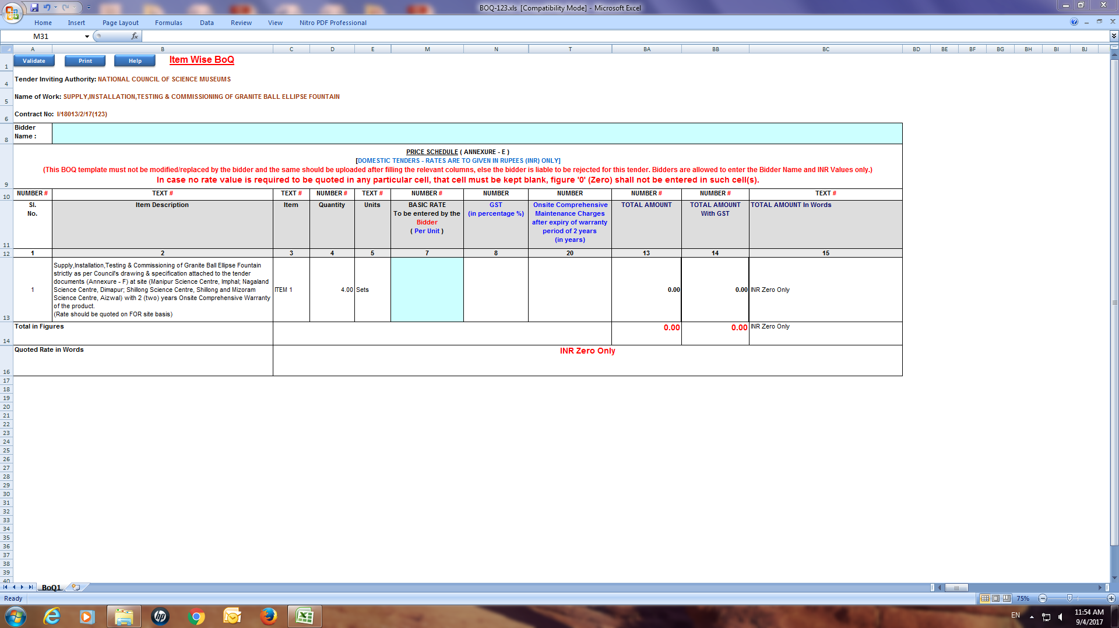

DRAWING ANNEXURE –F

(i)

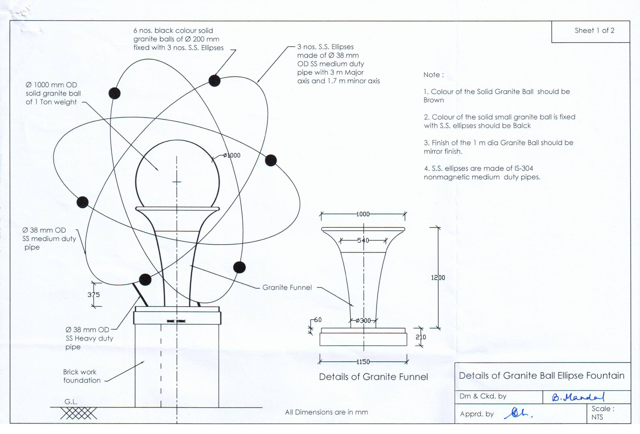

DRAWING ANNEXURE –F

(ii)

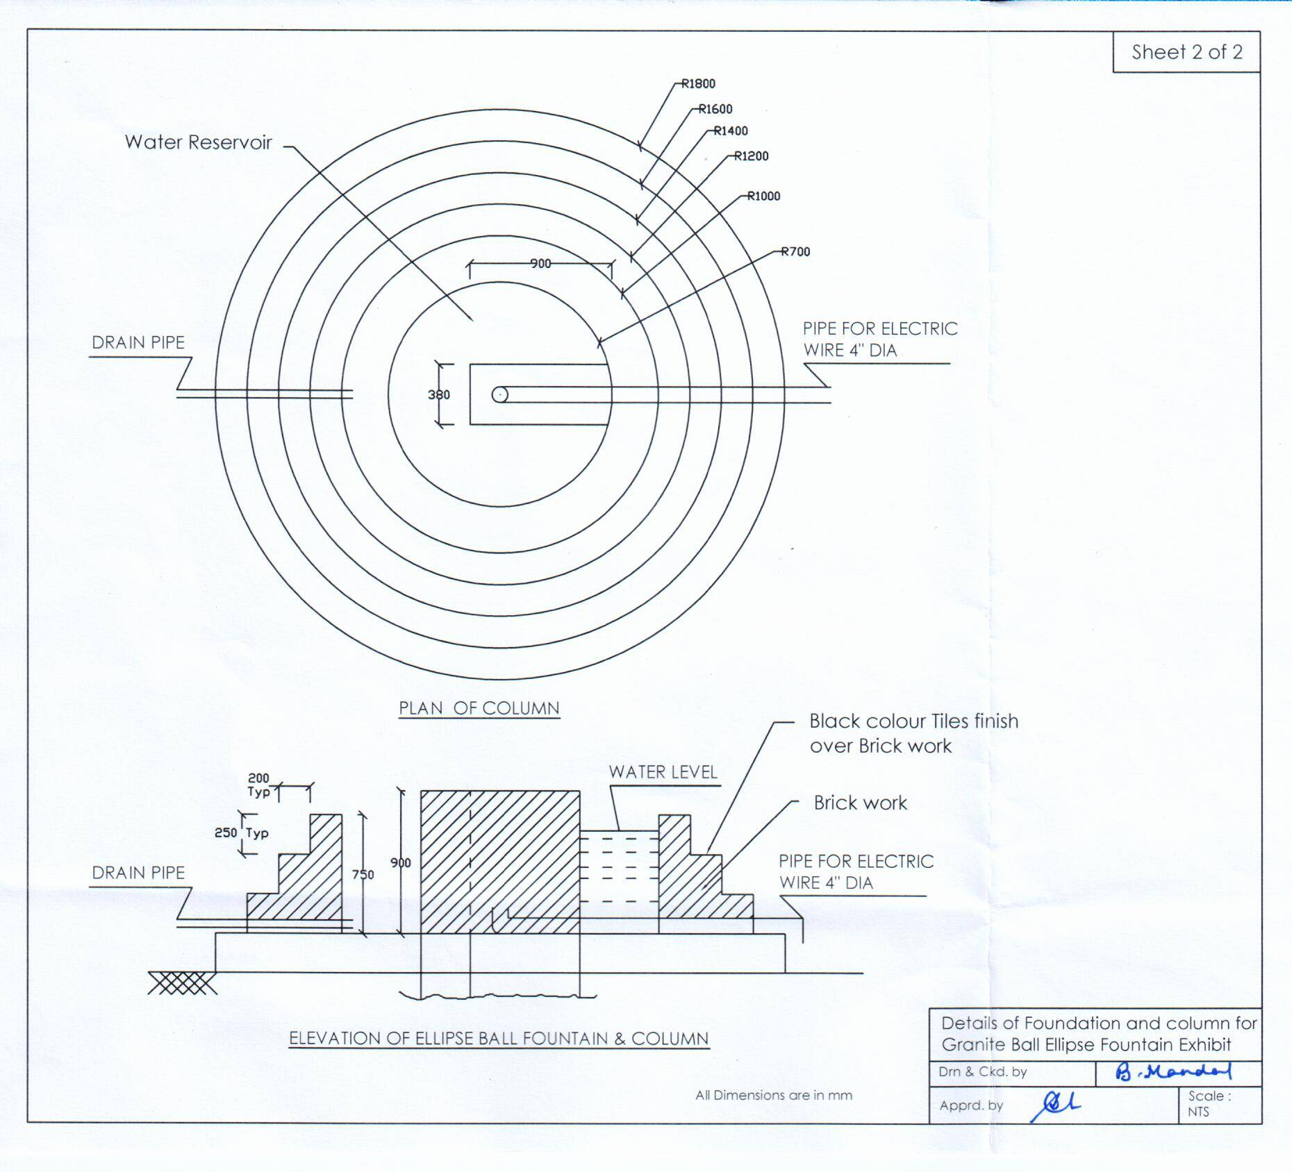

DRAWING ANNEXURE –F
(iii)

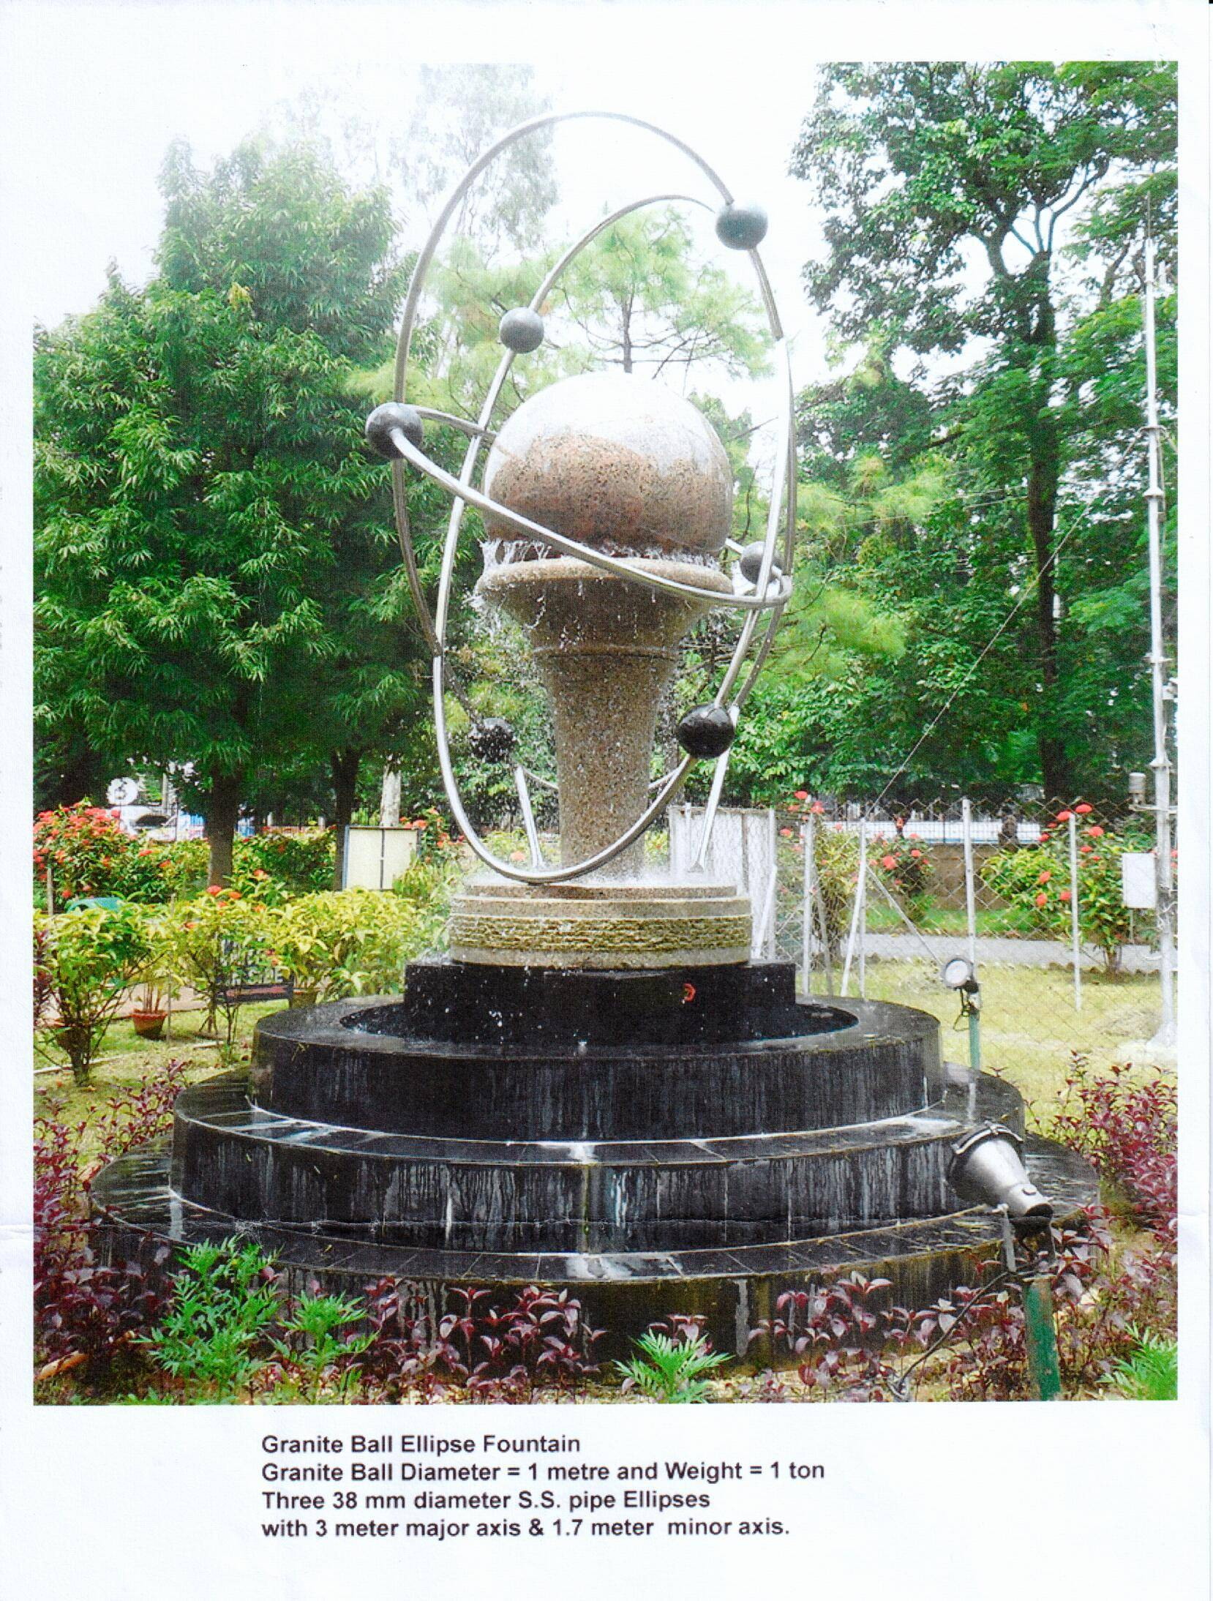

ANNEXURE –F

NATIONAL COUNCIL OF SCIENCE MUSEUMS
SECTOR-V, BLOCK-GN, BIDHANNAGAR
KOLKATA : 700 091.

TENDER No. I-18013/2/17(123)

TECHNICAL SPECIFICATION

