NATIONAL COUNCIL OF SCIENCE MUSEUMS
SECTOR-V, BLOCK-GN, BIDHANNAGAR,
KOLKATA : 700 091.

NOTICE INVITING E-TENDER

TENDER NO. I-18012/6/17(229)

On-line Digitally signed e-tenders are invited in two Bid System from the reputed and experienced manufacturers for Supply, Erection, Installation, Testing and Commissioning of “CNC Turning Centre/Machine” as per Council’s specification at this office. Only reputed manufacturers having proven experience in producing similar product and capability to execute the job within scheduled time frame may download the tender documents from the Central Public Procurement Portal (CPPP): http://eprocure.gov.in/eprocure/app or from the Council’s website www.ncsm.gov.in. Bid submission end date is February 08, 2018. Online Technical (Techno-Commercial) Bid will be opened at the first instance in this office on February 09, 2018 at 12 p.m. for technical evaluation as well as selection of techno-commercially acceptable offers and at the second stage, the Financial Bids of only the selected and techno-commercially acceptable equipment/offers are scheduled to be opened on February 15, 2018 at 3 p.m. subject to completion of Technical Evaluation. Off-line tenders shall not be accepted and no request in this regard will be entertained whatsoever. Decision of the Council regarding selection of eligible and qualified vendors/firms for opening the Financial Bid shall be final and binding on the bidders.

NATIONAL COUNCIL OF SCIENCE MUSEUMS
SECTOR-V, BLOCK-GN, BIDHANNAGAR,
KOLKATA : 700 091.

NOTICE INVITING E-TENDER

TENDER No. : I-18012/6/17(229)

On-line digitally signed e-tenders are invited from reputed manufacturers for Supply, Erection, Installation, Testing & Commissioning of “CNC Turning Centre /Machine” as per Council’s specifications. Vendors having proven experience and capability of executing the order at a time may download the Tender Papers from Central Public Procurement Portal (CPPP): http://eprocure.gov.in/eprocure/app or from Council’s website www.ncsm.gov.in as per the following schedule:-

Published Date | January 20, 2018
Bid Document Download Start Date | January 20, 2018
Bid Document Download End Date | February 08, 2018
Bid Submission Start Date | January 20, 2018
Bid Submission End Date | February 08, 2018 (up to 12 p.m.)
Technical Bid opening date | February 09, 2018 (at 12 p.m.)
Financial Bid opening date | February 15, 2018 (at 3:00 p.m.)
Earnest Money | INR 1,00,000 (Rupees One Lakh only)
The online bid both Technical (Techno-Commercial) Bid and Financial bid duly furnished in Cover-I and Cover-II respectively should be uploaded by the due date and time as per the above schedule. The responsibility to ensure this lies with the Bidder. Off-line tenders shall not be accepted and no request in this regard will be entertained whatsoever. Online Technical (Techno-Commercial) Bid will be opened at the first instance in this office at 12 pm on February 09, 2018 for technical evaluation as well as selection of techno-commercially acceptable offers and at the second stage, the Financial Bids of only the selected and techno-commercially acceptable equipment/offers are scheduled to be opened at 3 pm on February 15, 2018 subject to completion of Technical Evaluation of the offers. Decision of the Council regarding selection of eligible and qualified vendors/firms and or equipment in particular for opening the Financial Bid shall be final and binding on the bidders. Bidders may be present during opening of tenders.

NCSM reserves the right to accept or reject any or all tenders in full or part without assigning any reason whatsoever. NCSM shall also not be bound to accept merely the lowest tender but the technical suitability, capability and superiority of the equipment/system as well as after sales service including infrastructure to render such service etc. shall be of prime consideration for selection of the equipment.

General Information and Instructions

- The instruction given herein will be strictly binding on the tenderers and deviation, if any will make the tender or tenders liable to be considered invalid. Tenders incorporating additional conditions by the tenderer are liable for rejection.

2. Before submitting the tender, the tenderers shall examine carefully the technical specifications for supply, erection, installation & commissioning of CNC Turning Centre/Machine as per the Technical specifications enclosed with the tender of the National Council of Science Museums, Kolkata.

- Bids shall be submitted online only at CPPP website: https://eprocure.gov.in/eprocure/app Manual bids shall not be accepted.

- The instruction given in “Annexure-A” for “Instruction for Online Bid Submission” should be strictly followed during submission of the Bid.

- Bid documents may be scanned with 100 dpi with black and white option which helps in reducing size of the scanned document.

- Bid should be submitted along with the Earnest Money of Rs. 1,00,000/- (Rupees One Lakh only) by way of crossed Demand Draft/Pay Order on any nationalized bank of India payable in favour of “NATIONAL COUNCIL OF SCIENCE MUSEUMS, KOLKATA”. Earnest Money deposit in the form of Bank Guarantee bond or any other bond shall not be accepted and shall be rejected straightway. Earnest Money deposits in respect of such offers which are not accepted will be returned to the Bidders within 30 working days from the date on which the final decision is taken about the source from which the items under tender are to be procured or within 2 (two) months from the date of the opening of the tenders, whichever is earlier. Earnest Money deposit in respect of the successful bidders will be retained with the Council until entire execution of the order as per terms of the tender. If the successful bidder fails to execute the order strictly as per the Council’s specification in full or part within the stipulated delivery period of the purchase order, the Earnest Money deposit retained with the Council shall be forfeited forthwith after cancellation of the concerned order. No interest will be paid on the Earnest Money deposited with the Council.

- Validity of Bids: The Bids should remain valid for 180 days from the date of bid opening.

- Rejection of Bids: Canvassing by the Bidder in any form, unsolicited letter and post-tender correction may invoke summary rejection. Conditional tenders will be rejected. Non-compliance of applicable General Information and Instruction will disqualify the Bid.

- The tenderers should have Digital Signature Certificate (DSC) for filling up the Bids. The
Person signing the tender documents should be authorized for submitting the on line e-tender.

- The Financial Bid (BOQ) shall be filled in and signed by the authorized signatory online as per Proforma “Annexure-E” available at Central Public Procurement Portal e-tender system website http://eprocure.gov.in/eprocure/app. Off line Financial Bid shall not be accepted.

- Tender must be uploaded in two separate covers marked Cover-1 and Cover-2. The contents of Cover-1 and Cover-2 will be as follows:-

Cover-1

- Scanned copy of General Terms & Conditions as detailed in Annexure-B duly signed by the
authorised signatory with official stamp as a token of acceptance of the Terms & Conditions.

- Copy of the current and valid Trade License and/or Dealership Certificate, as applicable, duly
signed by the authorised signatory with official stamp.

- Scanned Copy of the current and valid GST Registration Certificate indicating GST number
duly signed by the authorized signatory with official stamp. (Please note that Provisional GST Registration Certificate is also acceptable for the time being)

- The scanned copy of the Demand Draft/Pay Order for Rs.1,00,000/- (Rupees One Lakh
only) as Earnest Money Deposit .

- The ‘Declaration’ of the bidder( as detailed in Annexure-C)duly signed by the authorized
signatory with official stamp.

- Technical (Techno-Commerical) bid as per “Annexure-D” format duly filled in and signed by the
authorised signatory with official stamp.

- Scanned copies of the Council’s Technical Specification (as detailed in Annexure-F)
duly signed by the authorized signatory with official stamp as a token of acceptance for supply &
installation of the machine including its accessories in accordance to the same, if agreed.

ix) Scanned copies of Technical Compliance Sheet (as detailed in Annexure – G) duly filled in and signed by the authorized signatory with official stamp.

Cover-2
The Financial Bid ( as per Annexure-E format) i.e. Schedule of Price Bid in the form of attached BOQ Proforma shall be duly filled in, digitally signed and uploaded online by the bidder.

The Cover-1, i.e. Technical (Techno-Commercial) Bid shall be opened by the Council at the first instance and evaluated by the competent authority of the Council. At the second stage, the Cover-2 containing Financial Bid of only techno-commercially acceptable offers shall be opened for further evaluation and ranking before awarding the contract.

- The authorities of National Council of Science Museums, who does not bind themselves to
accept the lowest tender, reserves the right to reject or accept any or all tenders wholly or partially without assigning and reason whatsoever.

ANNEXURE -A
NATIONAL COUNCIL OF SCIENCE MUSEUMS
SECTOR-V, BLOCK-GN, BIDHANNAGAR,
KOLKATA – 700 091.

TENDER No.: I-18012/6/17(229)

Instructions for Online Bid Submission
- The bidders are required to submit soft copies of their bids electronically on the CPP Portal, using valid Digital Signature Certificates. The instructions given below are meant to assist the bidders in registering on the CPP Portal, prepare their bids in accordance with the requirements and submitting their bids online on the CPP Portal.
- More information useful for submitting online bids on the CPP Portal may be obtained
at https://eprocure.gov.in/eprocure/app

REGISTRATION
  - Bidders are required to enroll on the e-Procurement module of the Central Public Procurement Portal (URL: https://eprocure.gov.in/eprocure/app ) by clicking on the link “Online bidder Enrollment” on the CPP Portal which is free of charge.
  - As part of the enrolment process, the bidders will be required to choose a unique username and assign a password for their accounts.
  - Bidders are advised to register their valid email address and mobile numbers as part of the registration process. These would be used for any communication from the CPP Portal.
  - Upon enrolment, the bidders will be required to register their valid Digital Signature Certificate (Class II or Class III Certificates with signing key usage) issued by any Certifying Authority recognized by CCA India (e.g. Sify / nCode / eMudhra etc.), with their profile.
  - Only one valid DSC should be registered by a bidder. Please note that the bidders are responsible to ensure that they do not lend their DSC’s to others which may lead to misuse.
  - Bidder then logs in to the site through the secured log-in by entering their user ID / password and the password of the DSC / e-Token.
SEARCHING FOR TENDER DOCUMENTS
  - There are various search options built in the CPP Portal, to facilitate bidders to search active tenders by several parameters. These parameters could include Tender ID, Organization Name, Location, Date, Value, etc. There is also an option of advanced search for tenders, wherein the bidders may combine a number of search parameters such as Organization Name, Form of Contract, Location, Date, Other keywords etc. to search for a tender published on the CPP Portal.

  - Once the bidders have selected the tenders they are interested in, they may download the required documents / tender schedules. These tenders can be moved to the respective ‘My Tenders’ folder. This would enable the CPP Portal to intimate the bidders through SMS / e-mail in case there is any corrigendum issued to the tender document.
  - The bidder should make a note of the unique Tender ID assigned to each tender, in case they want to obtain any clarification / help from the Helpdesk.
PREPARATION OF BIDS
- Bidder should take into account any corrigendum published on the tender document before submitting their bids.
- Please go through the tender advertisement and the tender document carefully to understand the documents required to be submitted as part of the bid. Please note the number of covers in which the bid documents have to be submitted, the number of documents - including the names and content of each of the document that need to be submitted. Any deviations from these may lead to rejection of the bid.
- Bidder, in advance, should get ready the bid documents to be submitted as indicated in the tender document / schedule and generally, they can be in PDF / XLS / RAR / DWF/JPG formats. Bid documents may be scanned with 100 dpi with black and white option which helps in reducing size of the scanned document.
- To avoid the time and effort required in uploading the same set of standard documents which are required to be submitted as a part of every bid, a provision of uploading such standard documents (e.g. PAN card copy, annual reports, auditor certificates etc.) has been provided to the bidders. Bidders can use “My Space” or ‘’Other Important Documents’’ area available to them to upload such documents. These documents may be directly submitted from the “My Space” area while submitting a bid, and need not be uploaded again and again. This will lead to a reduction in the time required for bid submission process.
SUBMISSION OF BIDS
- Bidder should log into the site well in advance for bid submission so that they can upload the bid in time i.e. on or before the bid submission time. Bidder will be responsible for any delay due to other issues.
- The bidder has to digitally sign and upload the required bid documents one by one as indicated in the tender document.
- Bidder has to select the payment option as “offline” to pay the tender fee/EMD as applicable and enter detail of the instrument.
- Bidder should submit the EMD as per the instructions specified in the tender document. The original should be posted/couriered/given in person to the Tender Processing Section, latest by the last date of bid submission. The detail of the DD/any other accepted instrument, physically sent, should tally with the details available in the scanned copy and the data entered during bid submission time. Otherwise the uploaded bid will be rejected.

- A standard Price Schedule format (BOQ) has been provided with the tender document to be filled by all the bidders. Bidders are requested to note that they should necessarily submit their financial bids in the format provided and no other format is acceptable. If the price bid has been given as a standard BOQ format with the tender document, then the same is to be downloaded and to be filled by all the bidders. Bidders are required to download the BOQ file, open it and complete the unprotected cells with their respective financial quotes and other details. No other cells should be changed. In case no rate value is required to be quoted in any particular cell, that cell must be kept blank, figure ‘0’ (zero) shall not be entered in such cell(s). Once the details have been completed, the bidder should save it and submit it online, without changing the filename. If the BOQ file is found to be modified by the bidder, the bid will be rejected.

- The server time (which is displayed on the bidders’ dashboard) will be considered as the standard time for referencing the deadlines for submission of the bids by the bidders, opening of bids etc. The bidders should follow this time during bid submission.

- All the documents being submitted by the bidders would be encrypted using PKI encryption techniques to ensure the secrecy of the data. The data entered cannot be viewed by unauthorized persons until the time of bid opening. The confidentiality of the bids is maintained using the secured Socket Layer 128 bit encryption technology. Data storage encryption of sensitive fields is done. Any bid document that is uploaded to the server is subjected to symmetric encryption using a system generated symmetric key. Further this key is subjected to asymmetric encryption using buyers/bid openers public keys. Overall, the uploaded tender documents become readable only after the tender opening by the authorized bid openers.

- The uploaded tender documents become readable only after the tender opening by the authorized bid openers.
- Upon the successful and timely submission of bids (ie after Clicking “Freeze Bid Submission” in the portal), the portal will give a successful bid submission message & a bid summary will be displayed with the bid no. and the date & time of submission of the bid with all other relevant details.
- The bid summary has to be printed and kept as an acknowledgement of the submission of the bid. This acknowledgement may be used as an entry pass for any bid opening meetings.

ASSISTANCE TO BIDDERS
- Any enquiries relating to the tender document and the terms and conditions contained therein should be addressed to the Tender Inviting Authority for a tender or the relevant contact person indicated in the tender.

- Any queries relating to the process of online bid submission or queries relating to CPP Portal in general may be directed to the 24x7 CPP Portal helpdesk. The contact number for the helpdesk is 1800 233 7315.

ANNEXURE-B

NATIONAL COUNCIL OF SCIENCE MUSEUMS
SECTOR-V, BLOCK-GN, BIDHANNAGAR,
KOLKATA: 700 091.

TENDER No. : I-18012/6/17(229).

GENERAL TERMS & CONDITIONS (GTC) FOR SUBMISSION OF TENDER FOR SUPPLY, ERECTION , INSTALLATION, TESTING & COMMISSIONING OF CNC TURNING CENTRE/MACHINE STRICTLY AS PER COUNCIL’S SPECIFICATIONS .

- Bidders should have necessary infrastructure and facilities so as to take up the job of supply of the tendered items strictly as per enclosed specifications and drawings with required financial capability.

- Price:
The prices and rates indicated/quoted shall be inclusive of cost of materials supply, erection, installation, testing & commissioning and all incidental charges to deliver the CNC Turning Centre/Machine at National Council of Science Museums, Sector-V, Block-GN, Bidhannagar, Kolkata: 700 091. The rate of GST to be imposed on the rate shall be clearly mentioned. Prices and rate quoted shall be firm and fixed for the entire period of execution of the order and no escalation of rate on any ground whatsoever shall be applicable.

- The successful bidders shall submit the following documents within 7(Seven) days from the date of Placement of the order:-

- Duplicate copy of the order duly signed and stamped as a token of acceptance of the order.

- Time is the essence of this tender. The delivery shall be made strictly as per following:-

Supply of the tendered item as per enclosed specifications and drawings, after obtaining due approval from the authority of the Council as detailed in Stage-I of clause 8, shall be made at National Council of Science Museums, Sector-V, Block-GN, Bidhannagar, Kolkata: 700 091 strictly within 45 (forty five) days from the date of placement of the order.

For non-compliance of any of the above terms and non-delivery of the tendered items, complete in all respects within the above stipulated delivery period, the Council shall have the right either to cancel the order after forfeiting the EMD amount or impose penalty as detailed in Clause No.05. Decision in this regard taken by the Council shall be final and binding on the successful bidder.

- Penalty Clause:-
The time allowed for executing the supply as detailed in Clause No.04 shall be strictly observed by the successful bidder. The supply shall throughout the stipulated period of the order, be proceeded with all the diligence (time being deemed to be the essence of the order) and the successful bidder shall pay to the Council, an amount equal to 1% of the amount of the contract value for every week that the supply may remain incomplete as per delivery schedule as stipulated in Clause No.04 subject to a maximum compensation of 10% of the contract value after which period, action will be taken by the Council as will deem fit.

The Council may extend the time of delivery of the ordered items at their discretion on the application of the successful bidder for such purpose provided that the Council considers the reasons for such extension as good, sufficient and acceptable.

- Every effort should be made to complete the supply by the successful bidder within the specified time schedule. In case the firm fails to comply with Clause No.04 within the specified time schedule as per the finalized and accepted terms & conditions, the Council shall have the right to either impose penalty clause or cancel the order forthwith and the earnest money deposit retained with the Council shall be automatically forfeited. The decision of the Council in this regard shall be final and binding on the successful bidder.

- Technical Specifications of the tendered job are enclosed for guidance. However, if any ambiguity in the specification is detected, it shall be promptly brought to the notice of the Council for clarifications. The successful tenderer without written approval/permission of the Council shall make no deviation from the approved Technical Specifications.

- Inspection Clause, Acceptance Criteria and Proving of the machine:-

Stage –I

The successful tenderer shall mandatorily arrange for Inspection of the equipment including its accessories as per given specifications and drawings at the manufacturing site (PDI) for the following within 25 days from the date of placing the order :-

i) proving the machine parameters to specification

ii) Technical acceptance as per successful tenderer’s standard test chart (Geometrical Test) with Laser Calibration

Stage-II

Final inspection of the equipment shall be conducted at National Council of Science Museums within 45 days from the date of placing the order and after delivery and successful installation of the machine for the following :-

i) Proving the machine parameters to specification

ii) Technical acceptance as per successful tenderer’s standard test chart (Geometrical Test) with Laser Calibration

The above two inspections will be made by the authorised officials of National Council of Science Museums. Any defect pointed out by the competent representative of National Council of Science Museums during such inspection has to be promptly rectified at the cost, including material cost of the successful tenderer(s) to meet the desired quality, and specification as per requirement of National council of Science Museums failing which action shall be taken as deemed fit by the National Council of Science Museums. The decision of National Council of Science Museums in this regard shall be final and binding on the successful tenderer(s).

09. Training:-

The successful tenderer shall arrange training in operation, programming and maintenance of the
machine to 3 Technical staff members of the Council for 3 consecutive days at their workshop
during PDI and the same training shall be arranged at the installation site (i.e. National Council of
Science Museums, Kolkata) also.

10. Payment terms:-
No advance payment shall be made by the Council on any circumstances. Payment shall be released within 30(thirty) working days from the date of receipt of Invoice/Bill(supplies covered under Stage-III of clause No.04) duly supported by receipted challan subject to satisfactory inspection report of the ordered materials issued by the competent authority of the Council.

11. Warranty:
Manufacturers’ Standard warranty certificate preferably valid for one year shall be provided along with the bill/invoice. The bidder shall be responsible for all defects of materials including defective workmanship, use of defective materials etc. for the entire warranty period of the manufacturer effective from the date of final acceptance of the ordered materials.

12. The materials shall be supplied by the bidder shall conform to the drawings and specifications given
by the Council. Sub-standard quality of materials & workmanship will not be accepted. The samples
must be got approved well in advance from the competent authority of the Council.

13. The raw materials supplied by the successful tenderer shall conform to the specification given
by the Council. Sub-standard quality of materials as well as workmanship will not be accepted. The
sample must be got approved well in advance from the competent authority of the Council

14. Bad workmanship will not be accepted and if carried out is liable to be rejected and should be
rectified by the supplier at his own cost & risk as per specifications and directions given by the
authorized representative of the Council.

15. The earnest Money deposit of the successful bidder for Rs.1,00,000/- (Rupees One lakh only) shall
be retained with the Council as Security Deposit until satisfactory execution of the Purchase Order.
In case of failure to execute the order in full or part within the stipulated delivery period of the
order or failure to adhere any of the terms & conditions of the Purchase Order, the Earnest Money
deposit/Security Deposit retained with the Council shall be forfeited forthwith after cancellation of
the concerned Purchase Order.

16. Income Tax shall be deducted at source, from each bill/claim of the firm as per prevailing
Government rules.

17. If it is noticed that the goods supplied do not conform to the specification/drawing of the order, the
Council shall have the right to reject the materials in part or full. The supplier shall be liable to
replace the rejected materials within the stipulated time. Till the replacement is done, the rejected
materials shall be lying at the risk, cost and responsibility of the supplier. If the supplier do not
arrange to replace the rejected materials within the stipulated time, the same may be disposed off
at the risk of the supplier and in the manner which the Council will deem fit. The Council shall be
entitled to retain the proceeds of the disposal either in part or in full towards expenses incurred on
storage, handling and disposal of the materials. The Council shall also be entitled to recover the
expenses made by them on account of storage & handling of such rejected goods till the goods are
removed from the premises of the Council.

18. In case the bidder refuse to accept the offer after finalization or does not comply with the Clause
no.03 within 15(fifteen) days from the date of placement of the order as per the finalized and
accepted terms & conditions, earnest money deposit would be automatically forfeited and the
order shall be cancelled forthwith.

19. The authorities of the National Council of Science Museums reserves the right to amend, alter or
modify the terms & condition mentioned above if necessary from time to time.

20. The authorities of National Council of Science Museums, who does not bind themselves to accept
the lowest tender, reserves the right to reject or accept any or all tenders wholly or partially
without assigning and reason whatsoever.

21. The quantities specified in the tender may be decreased or increased at the sole discretion of NCSM
authorities.

22. All disputes and differences between the successful bidder and the Council of any kind except
quality of workmanship and materials whatever arising out of or in connection with the order on
carrying out the supply (whether during the progress of the work or after their completion and
whether before or after the determination, abandonment or breach of the Terms & conditions of
the order) shall be referred to the sole arbitration of a person nominated by the Director General,
National Council of Science Museums, whose decision in this regard will be final and binding on
both the successful bidder and the Council.

The provisions of the Arbitration and Reconciliation Act 1996 or any statutory modification or re-enactment thereof and of the rules made there under for the time being in force shall apply to arbitration’s proceedings under this Clause.

**************************************

ANNEXURE-C

NATIONAL COUNCIL OF SCIENCE MUSEUMS
SECTOR-V, BLOCK-GN, BIDHANNAGAR
KOLKATA : 700 091.

TENDER No. I-18012/6/17(229)

DECLARATION

We do hereby accept the “General Terms & Conditions” as provided by the National Council of Science Museums along with the Tender documents for Supply, Erection, Installation, Testing & Commissioning of CNC Turning Centre/Machine and also under take to supply and install the said materials strictly as per the specifications of National Council of Science Museums as provided along with the tender documents, in the event of placement of any order on us. The Council shall be at liberty to cancel the order in full or in part and also forfeit the earnest money deposit or security deposit in the event of failure of any of the above declaration made by us.

Signature of the Bidder / Constituted Attorney.

ANNEXURE-D

NATIONAL COUNCIL OF SCIENCE MUSEUMS
SECTOR-V, BLOCK-GN, BIDHANNAGAR,
KOLKATA – 700 091.

TENDER No.: I-18012/6/17(229)

TECHNICAL (Techno-Commercial) BID

Notes: ALL PARTICULARS / INFORMATIONS SHOULD BE GIVEN IN THE FOLLOWING FORMAT WITH COMPLETE DETAILS.

01. Name & Address of the Firm/Bidder :

02. Telephone Number :

Office :

Workshop :

e-mail :

Fax :

- i) Back ground details of the firm :
(State whether original manufacturer/direct
dealer of the manufacturer).

ii) In case of direct dealers, submit copy of valid :
dealership license issued by the manufacturer.

- Past experience in such business for last 3 years :
giving details of established clients especially
Government offices. Submit satisfactory
certificate issued by such clients and
Government offices.

05. i) Whether capable to supply the tendered :
CNC Turning Centre/Machine strictly as per
enclosed technical specification.
(Please mention ‘YES’ or ‘NO’)

ii) If it is mentioned ‘NO’ above, submit :
detailed deviation to be made from the
enclosed technical specification.
(Extra sheet may be attached, if required).
iii. If it is mentioned ‘YES’ above submit :
copies of product brochure (for product
categories) as a proof of their statement.

Contd…….Page/2

-: 2 :-
iv) State whether the CNC Turning Centre/Machine :
to be offered by the firm either come with
or in compliance with all the features as
detailed in enclosed Specification.
(State YES or NO)

07. State whether the equipment offered complies
with the “Certificate of Conformity (CE)” issued by
the concerned regulatory authority.
(State “Yes” or “No”)

i) If the answer above is “Yes”, submit copy of
the documentary evidence.

08. State the Name & Address of the :
Manufacturer whose product
has been offered / quoted by the tenderer.

09. State the Names and addresses of the organizations :
Including Govt. companies/establishment/institutions
where the tendered machines supplied & installed and
still in operation.
( Attach Extra Sheet, if necessary)

10. State whether submitted the “Technical Compliance Sheet”
duly filled in and signed.
(State “Yes” or “No”)

11. Submit the documentary evidence :
regarding execution of latest contract of
similar nature and magnitude of minimum
single order value of Rs. 10 Lakh.

12. Proof of financial status of the company/ :
audited Balance Sheet for last 3 years
indicating total turnover as well.
(Submit documentary evidence).

13. Whether agreed to accept 30 days credit Payment :
Terms. (Please mention ‘YES’ or ‘NO’. ).

14. Minimum time required to supply the :
tendered items at NCSM Hqrs. at Kolkata.

15. Mention GST Registration Number :
and attach current valid GST Registration
Certificate.

16. Whether agreed to supply the tendered :
items as per enclosed list positively by 45
(forty five) days and failing which ready to
absorb heavy penalty, if any order is placed
on the bidder after observing due tender
procedure. (Please mention ‘YES’ or ‘NO’).

I/We hereby declare that the above statements are true. I/We also declare that the decision of National Council of Science Museums regarding selection of eligible firms for opening of Financial Bid (Part-II) shall be final and binding on me/us.

Dated Official Seal Signature of the Tenderer/Constituted Attorney

ANNEXURE-E

PRICE SCHEDULE (BOQ)

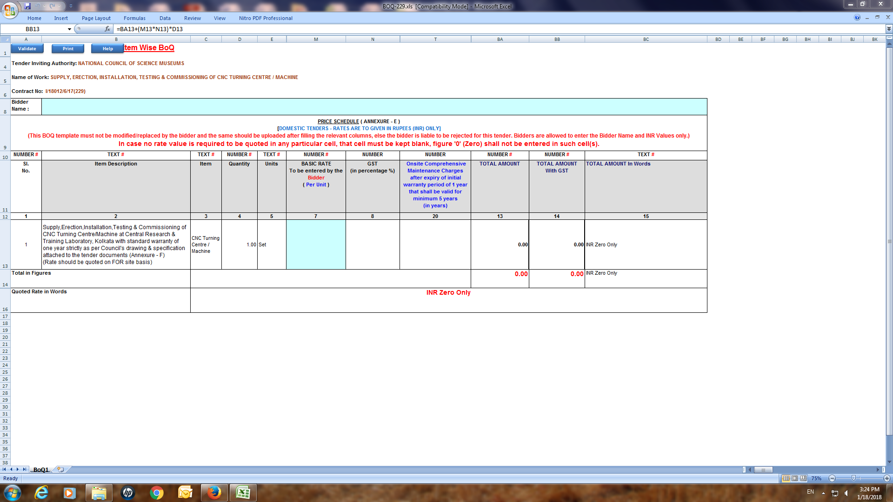

ANNEXURE –F
NATIONAL COUNCIL OF SCIENCE MUSEUMS
SECTOR-V, BLOCK-GN, BIDHANNAGAR
KOLKATA : 700 091.

TENDER No. I-18012/6/17(229)

TECHNICAL SPECIFICATION
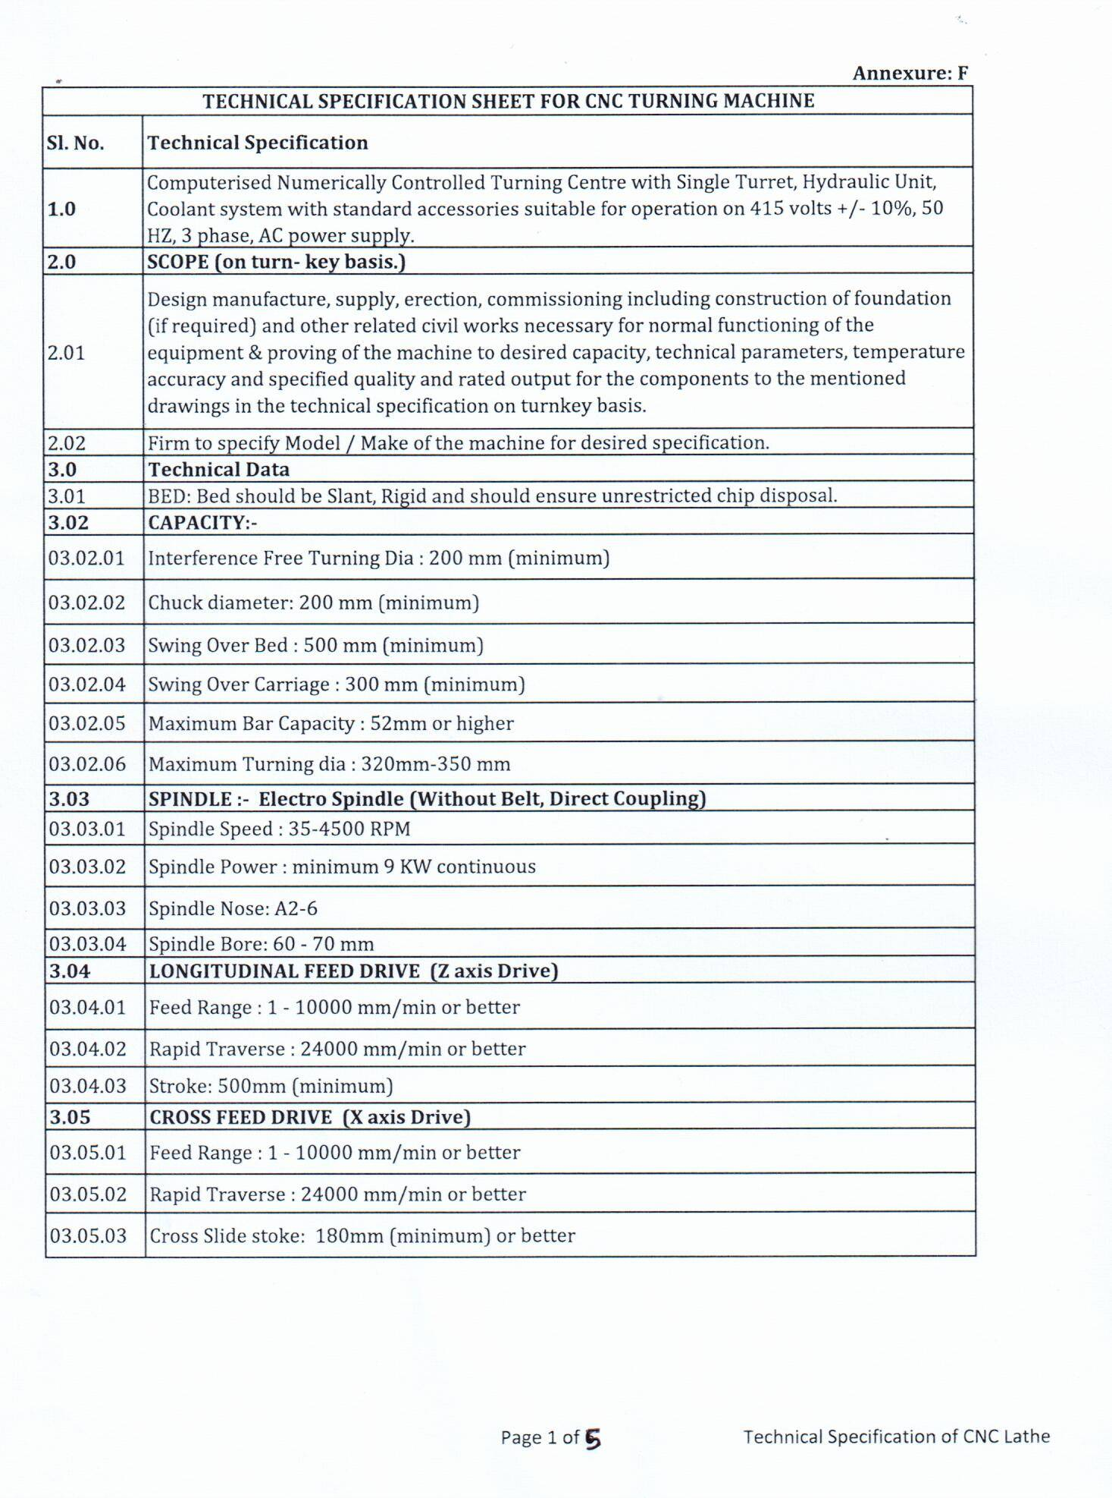

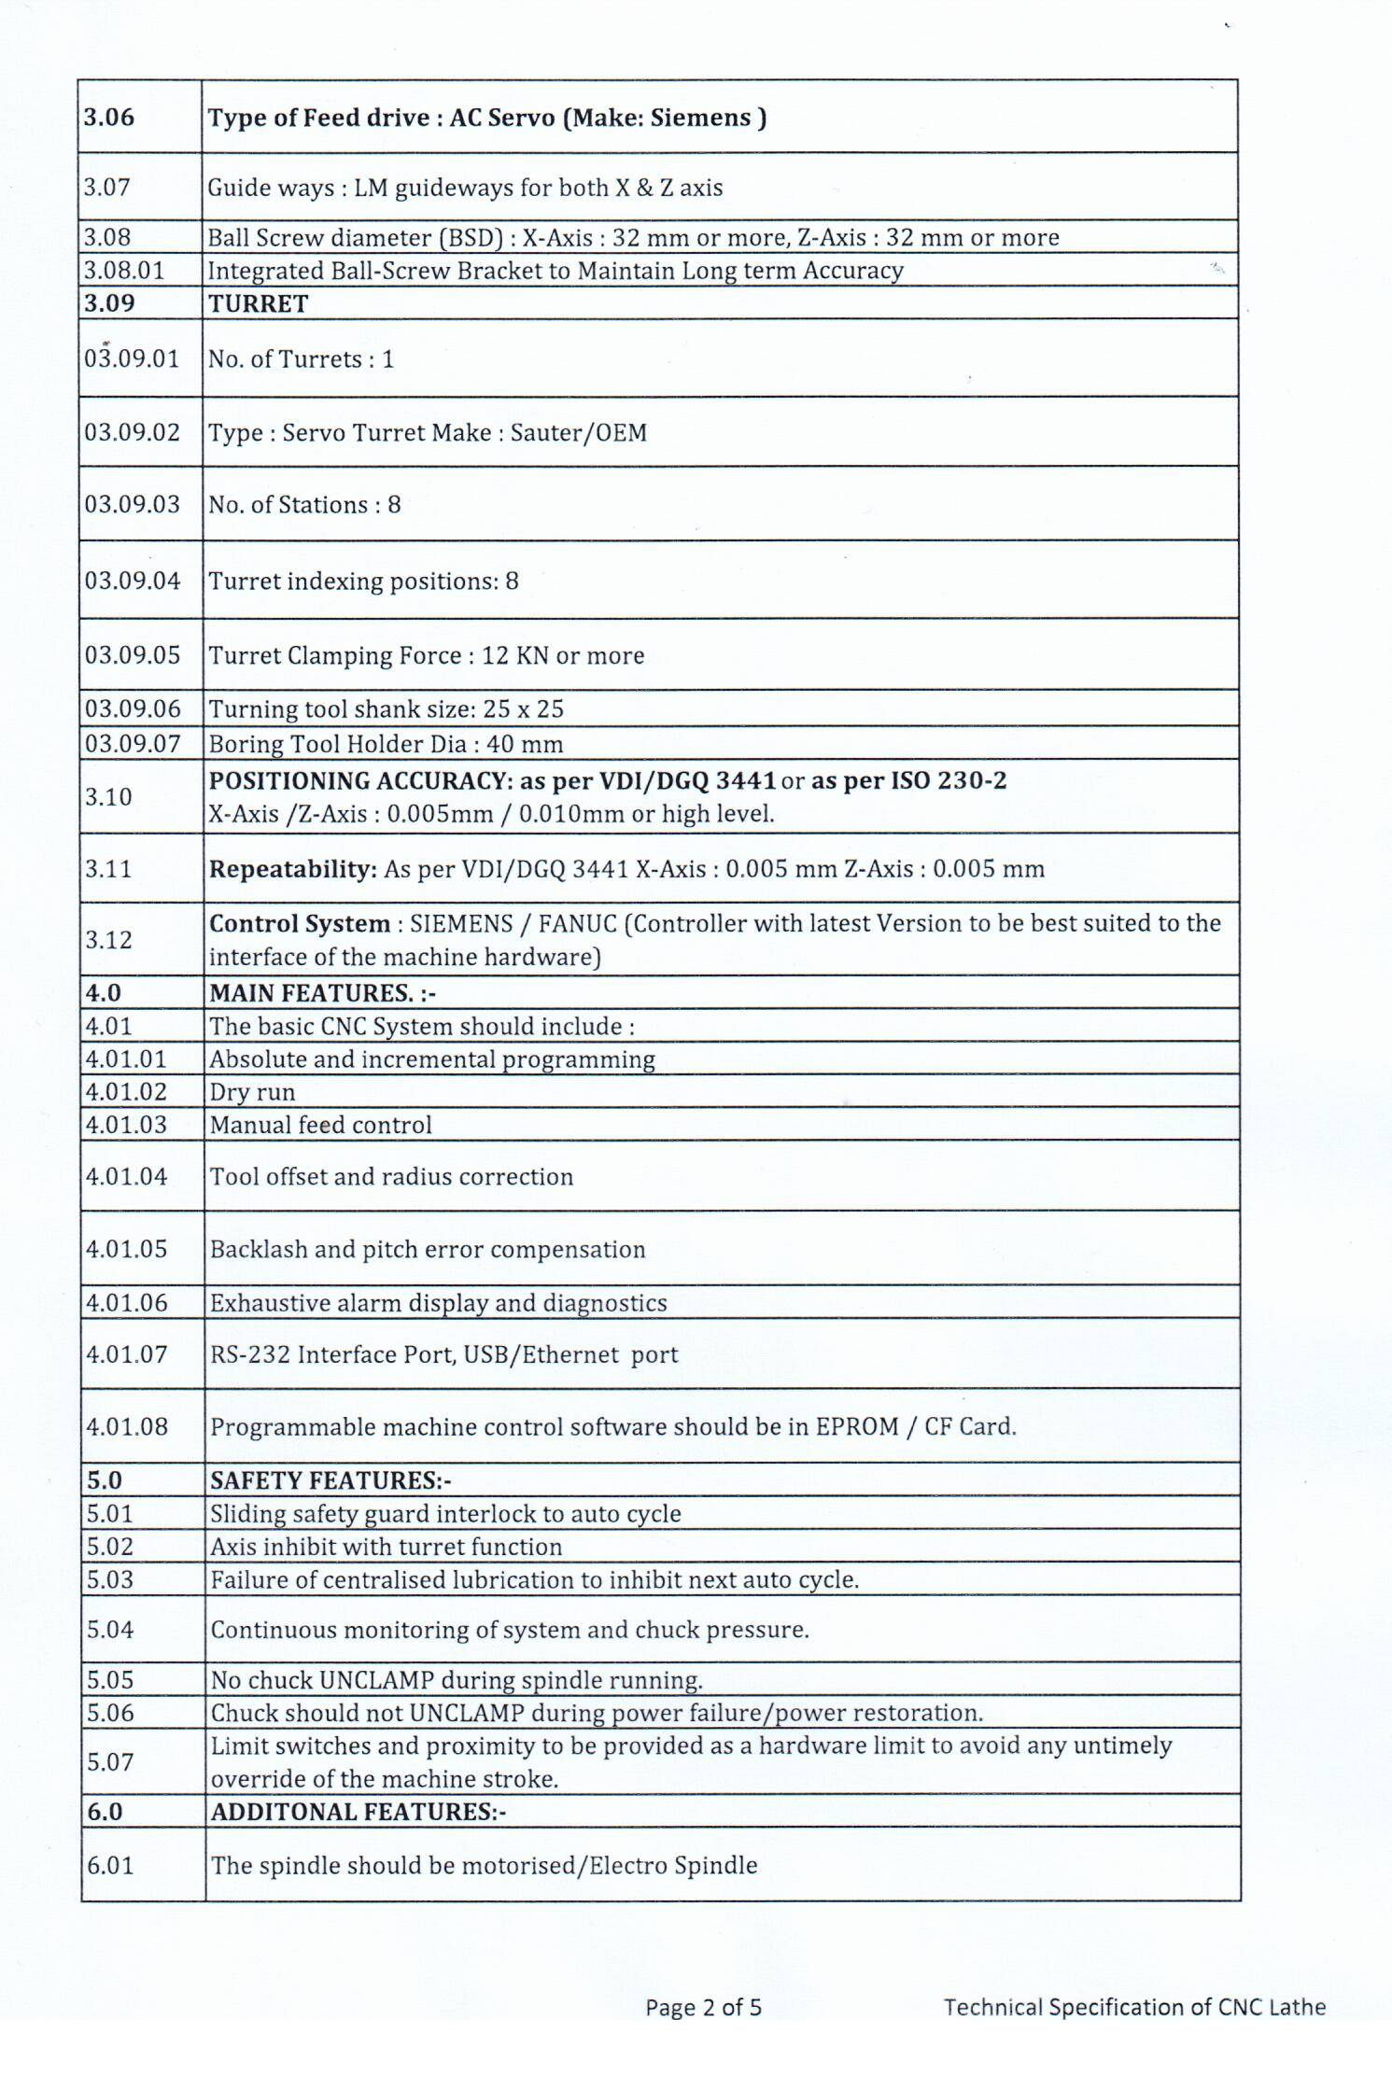

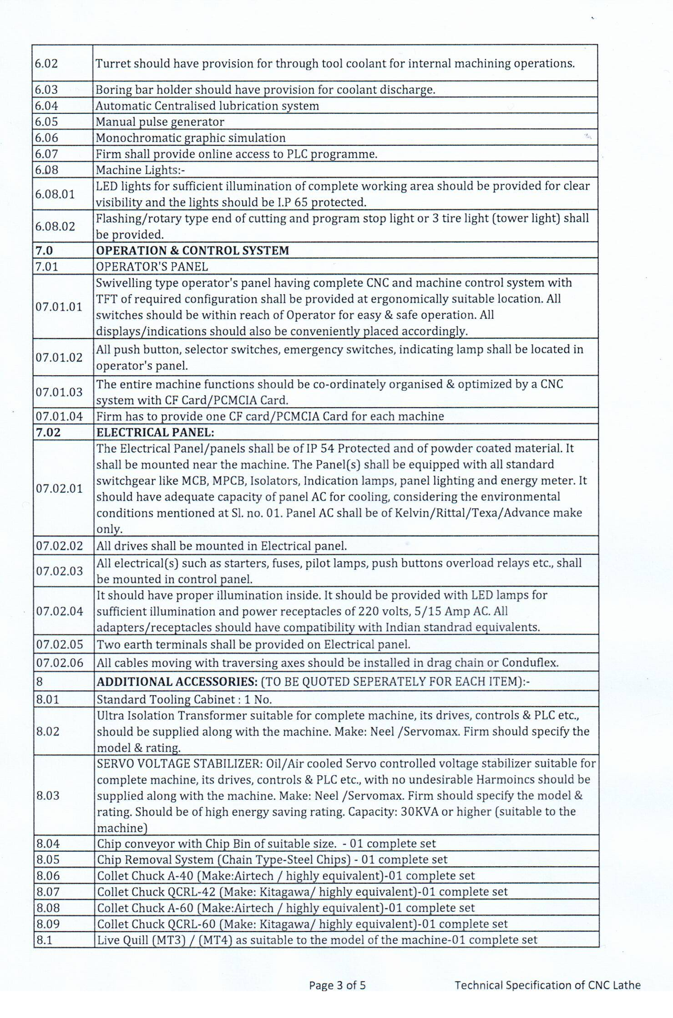

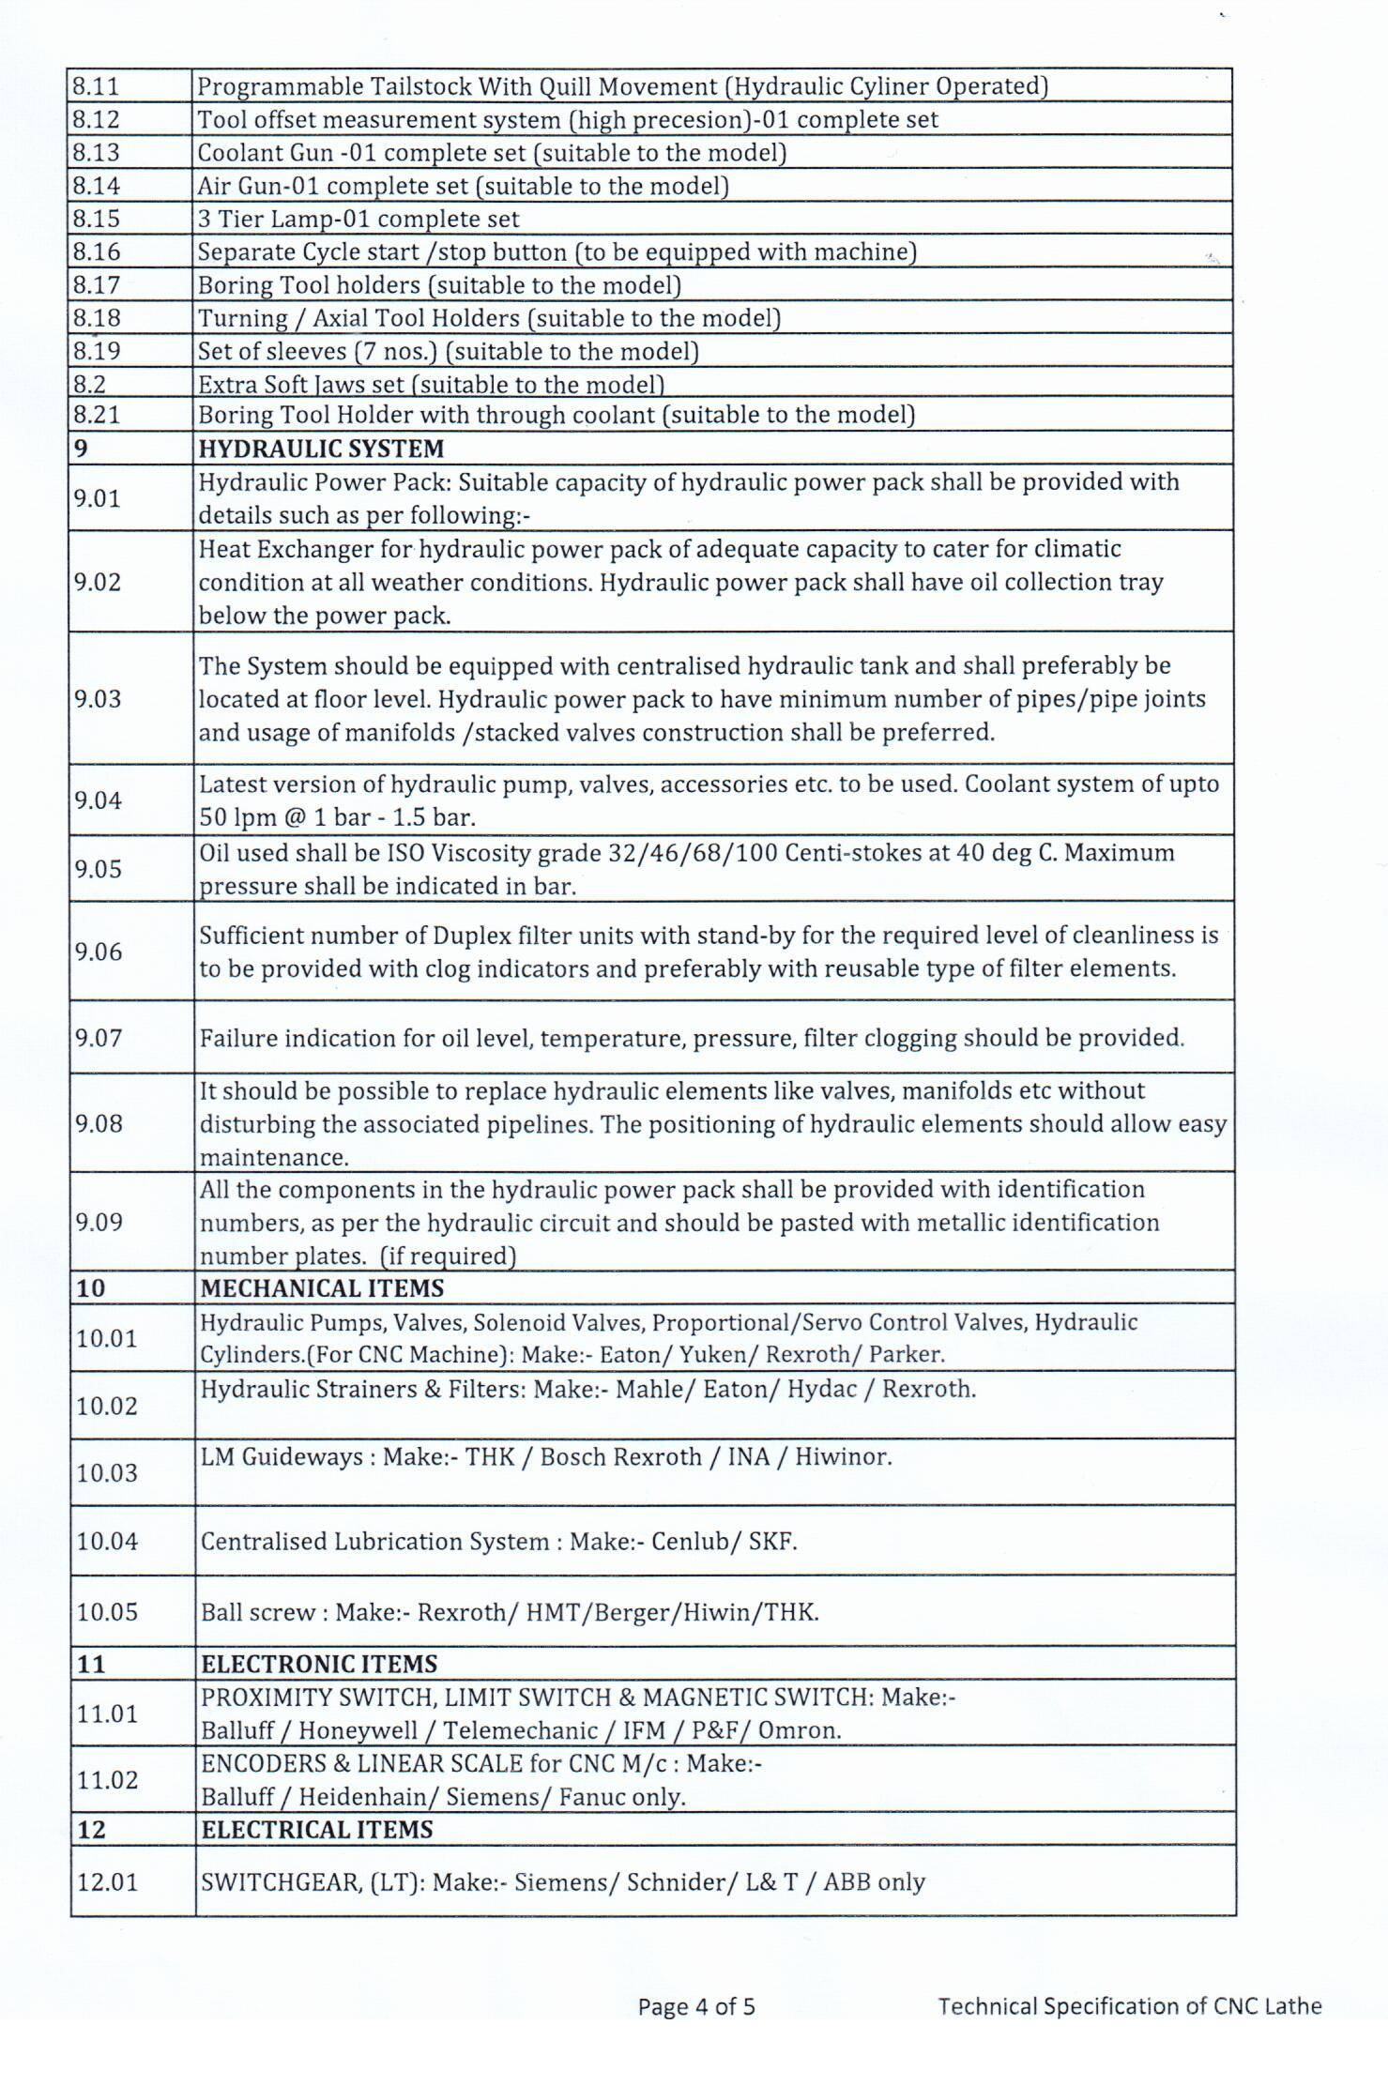

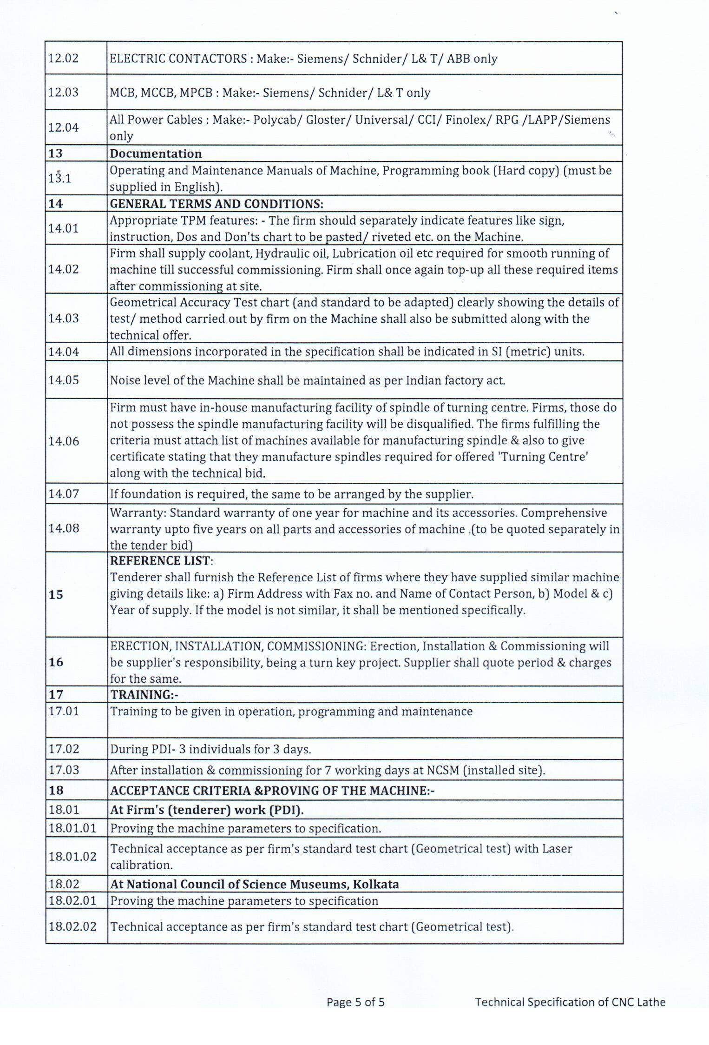

ANNEXURE –G

Technical Compliance of CNC Lathe

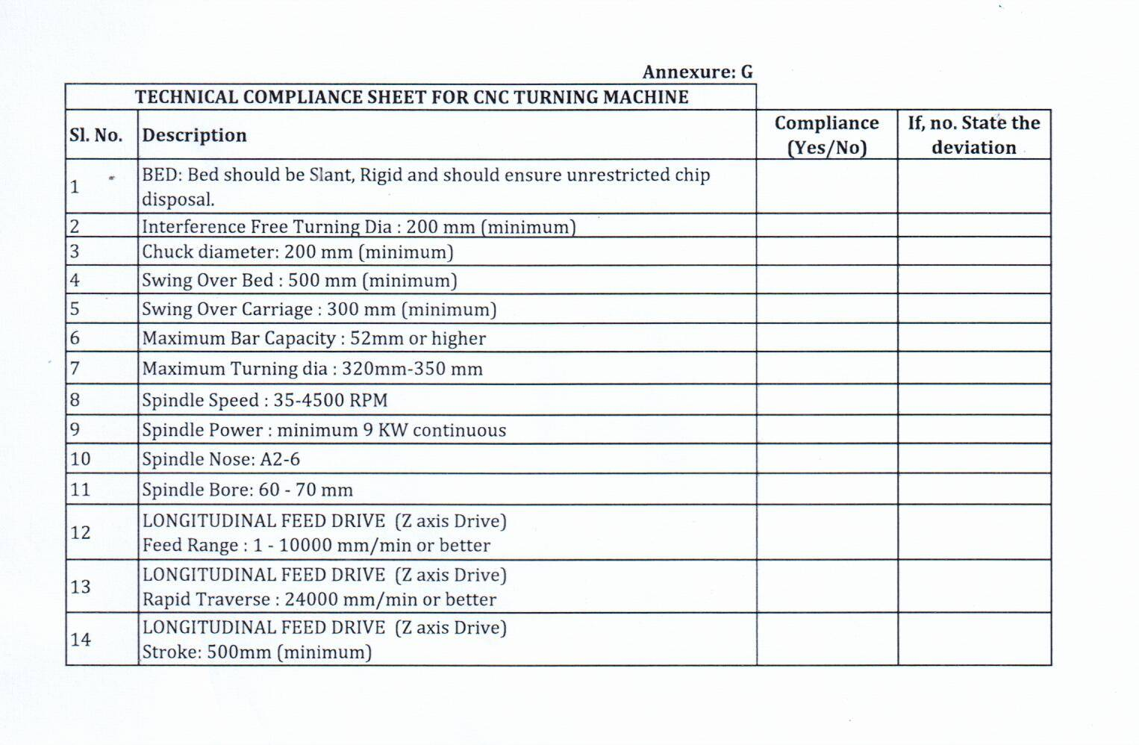

Page 1 of 5

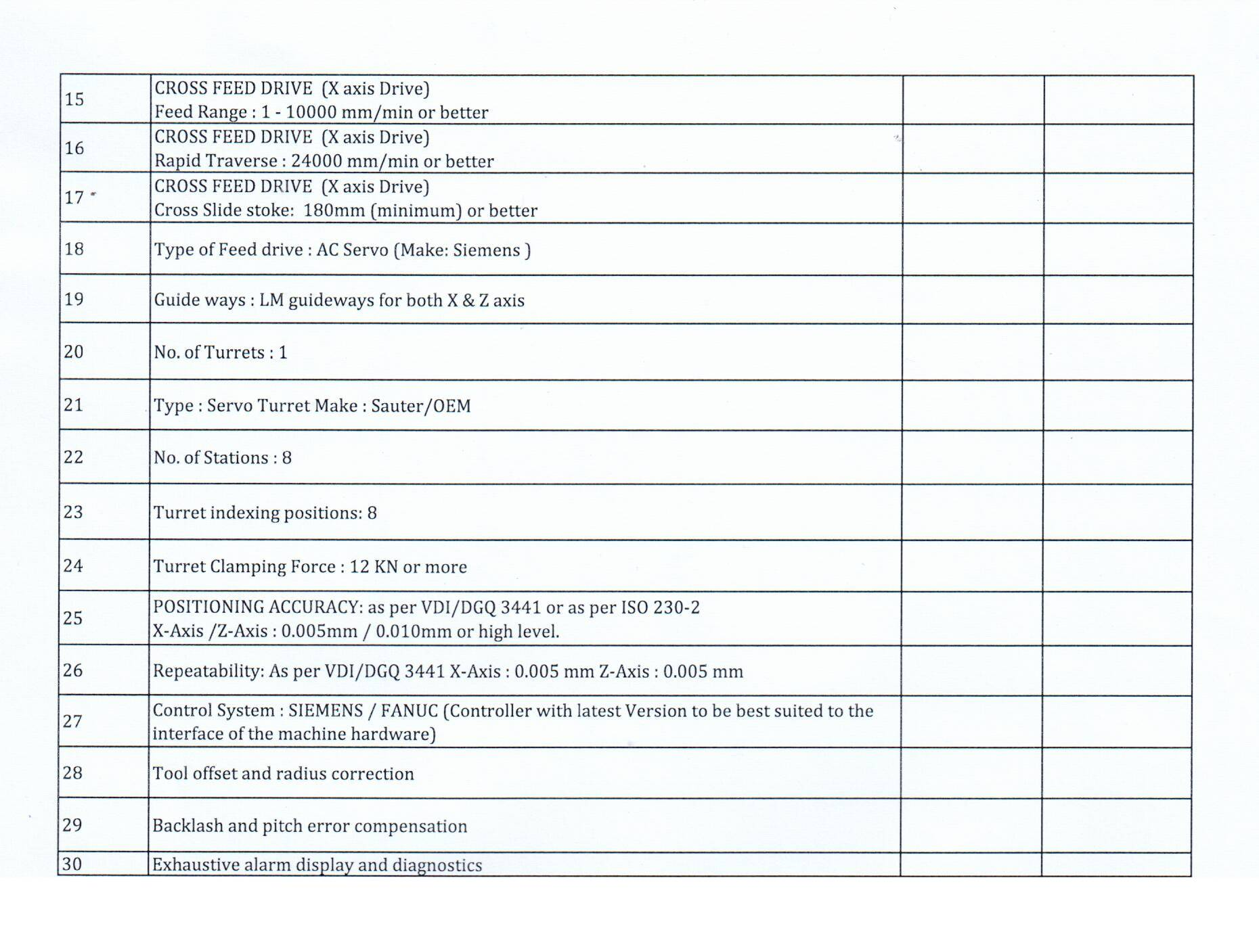

Page 2 of 5

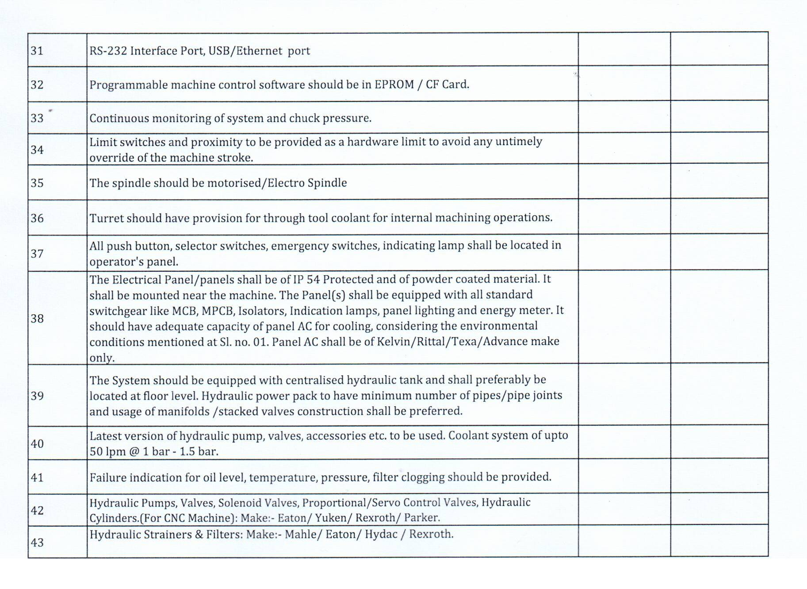

Page 3 of 5

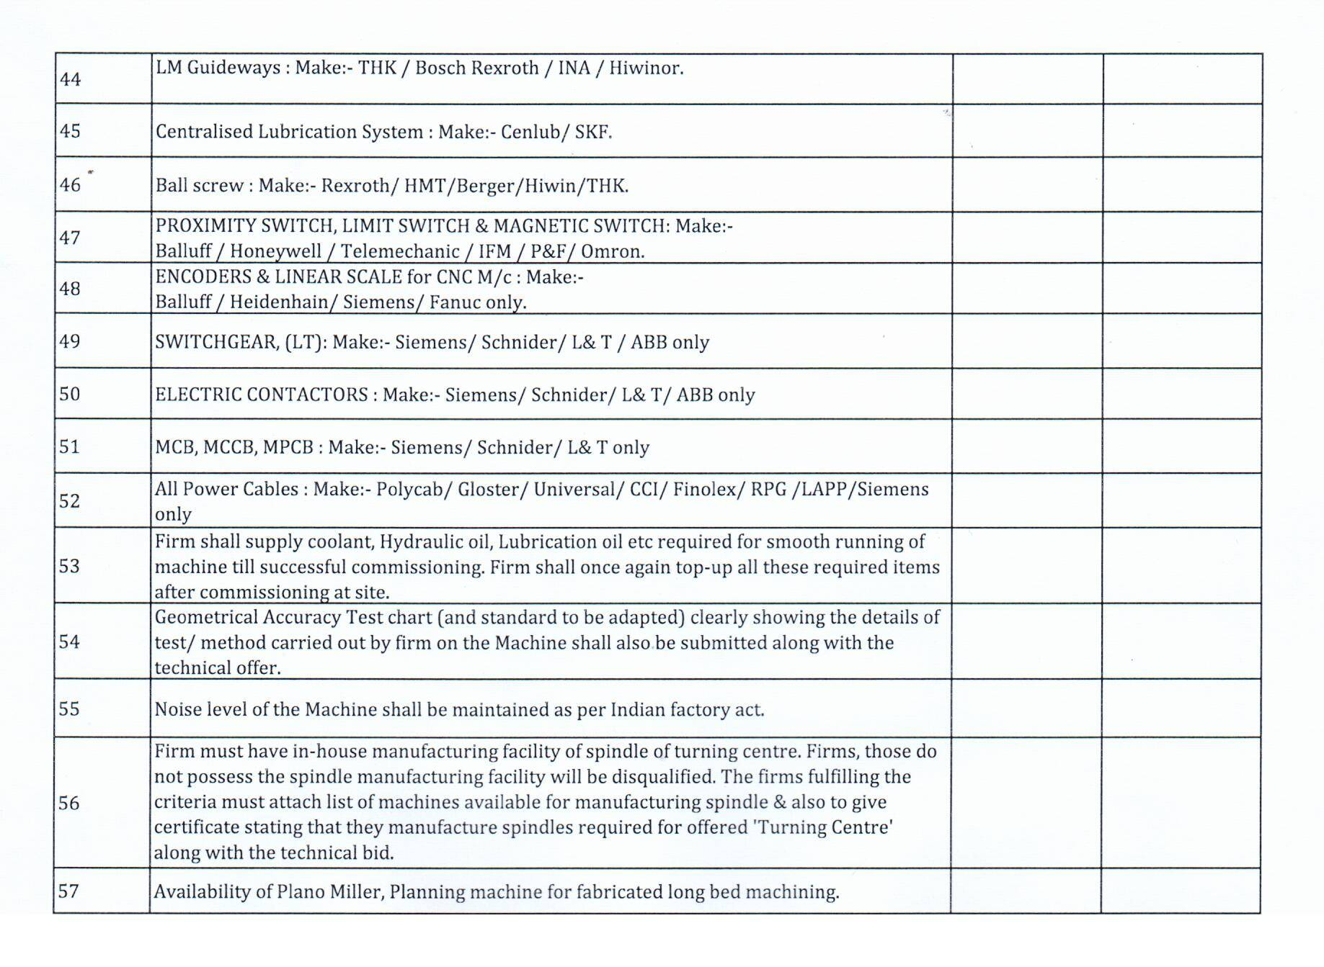

Page 4 of 5

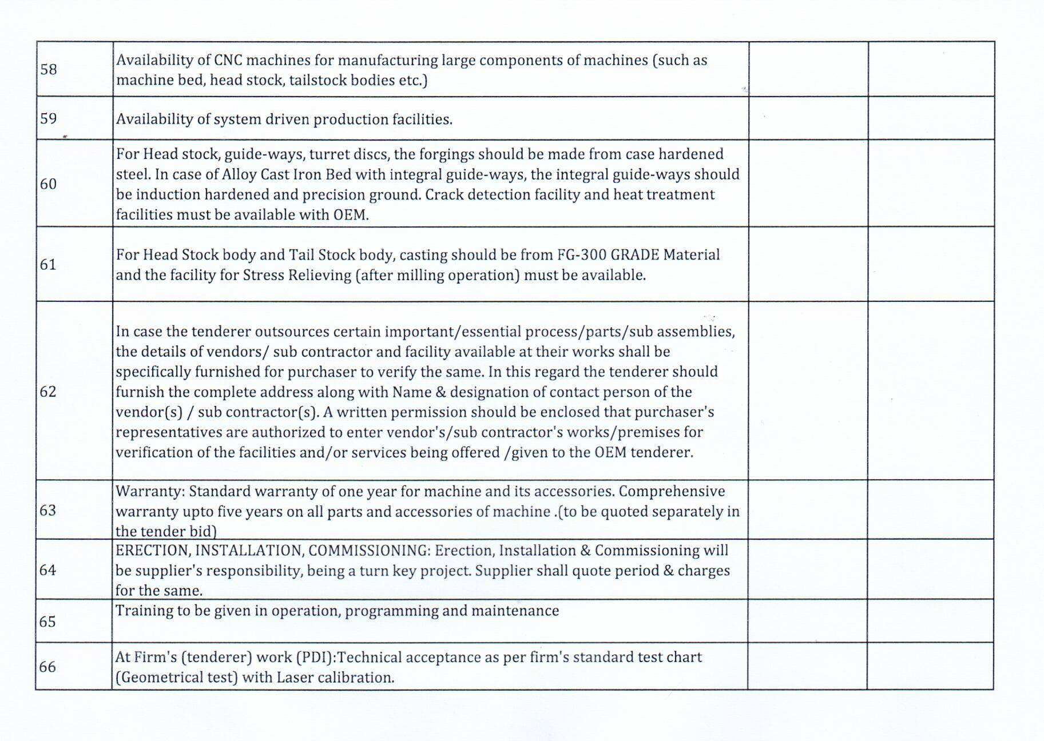

Page 5 of 5

