
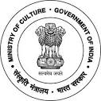
National Council of Science Museums
Ministry of Culture, Govt. of India

33, Block-GN, Sector- V, Salt Lake
Kolkata- 700091
Telephone- 033-2357-5545/9347/0850
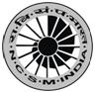
www.ncsm.gov.in
Notice Inviting E-Tender No. I-15014/76

E-Tender is invited for “Construction of basic peripheral Road for Sub- Regional Science Centre at Bodhgaya, Gaya” at an estimated cost of `27,89,106/-.

Please visit website http://eprocure.gov.in/eprocure/app and search with Tender Id: 2019_NCSM_485248_1 for details & online tendering. Tenders may be submitted between 11.07.2019 and 26.07.2019.

