
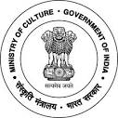
National Council of Science Museums
Ministry of Culture, Govt. of India

33, Block-GN, Sector- V, Salt Lake
Kolkata- 700091
Telephone- 033-2357-5545/9347/0850
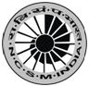
www.ncsm.gov.in
Notice Inviting E-Tender No. I-15014/11(26/4)19-20(E)

E-Tender is invited for “Repairing and Restoration work of Electrical Installations in Science Park & allied areas at Regional Science Centre, Bhubaneswar” at an estimated cost of `7,90,513/-.

Please visit website http://eprocure.gov.in/eprocure/app and search with Tender Id: 2019_NCSM_486084_1 for details & online tendering. Tenders may be submitted between 15.07.2019 and 29.07.2019.

