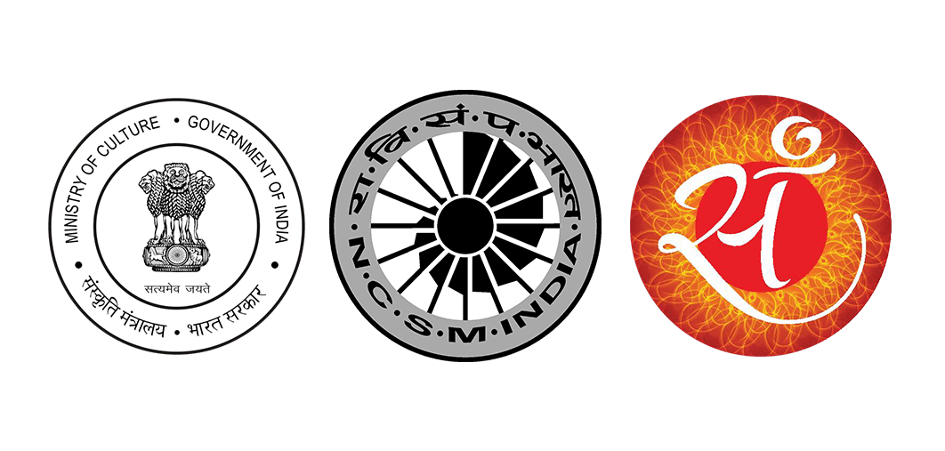

**NATIONAL COUNCIL OF SCIENCE MUSUEMS**

**(MINISTRY OF CULTURE, GOVERNMENT OF INDIA)**

**33, BLOCK-GN, SECTOR-V, BIDHAN NAGAR, KOLKATA-700091**

**Notice Inviting e-Tender No. I-17012/24 (MSE)**

E-tender is invited for *‘Providing Services for Organizing Mobile Science Exhibition’* for Regional Science Centre, Jawahar Nagar, Khanapara, Guwahati – 781 022.

Interested agencies, fulfilling the eligibility criteria, as prescribed in the e-NIT, may take part in the e-tendering process. Please visit CPP Portal [**https://eprocure.gov.in/eprocure/app**](https://eprocure.gov.in/eprocure/app)and search with **e-Tender ID No.: 2019_NCSM_485513_1** for details and online tendering. Tenders may be submitted between **11.07.2019 to 31.07.2019 upto 12:00 noon**.