
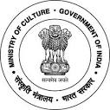
National Council of Science Museums
Ministry of Culture, Govt. of India

33, Block-GN, Sector- V, Salt Lake
Kolkata- 700091
Telephone- 033-2357-5545/9347/0850
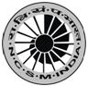
www.ncsm.gov.in
Notice Inviting E-Tender No. I-15014/76/(IH-SRSC(B)/2020

E-Tender is invited for “Infrastructural/Carpentry work for Setting up of Innovation Hub at Sub- Regional Science Centre, Bodhgaya, Gaya (Bihar)””.

Please visit website http://eprocure.gov.in/eprocure/app and search with Tender Id: 2020_NCSM_569571_1 for details & online tendering.

Tenders may be submitted between 08.07.2020 and 28.07.2020.

