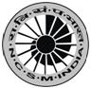
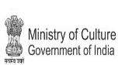
National Council of Science Museums
Ministry of Culture, Govt. of India
33, Block-GN, Sector- V, Salt Lake
Kolkata- 700091
Telephone- 033-2357-5545/9347/0850
www.ncsm.gov.in
Notice Inviting E-Tender No. I-15014/11(26)/PPA/21-22

E-Tender is invited for “Preparation of Detailed Project Report (DPR) for Setting up of the National Level Museum & Art Centre at Kunjaban Palace Complex with Pushpabanta Place, Durbar Hall and Ancillary Buildings at Agartala, Tripura”.

Please visit website http://eprocure.gov.in/eprocure/app and search with Tender Id: 2021_NCSM_626848_1 for details & online tendering. Tenders may be submitted between 19.04.2021 and 10.05.2021.

