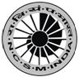
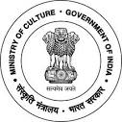
National Council of Science Museums
Ministry of Culture, Govt. of India
33, Block-GN, Sector- V, Salt Lake
Kolkata- 700091
Telephone- 033-2357-5545/9347/0850
www.ncsm.gov.in
Corrigendum regarding Notice Inviting E-Tender No.
I-15014/11(26)/PPA/21-22

The last date for submission of e-tender related to Preparation of DPR for Setting up of the National Level Museum and Art Centre at Kunjaban Palace Complex with Pushpabanta Palace Durbar Hall and Ancillary Buildings at Agartala Tripura has been extended upto 24.05.2021.

Please visit website http://eprocure.gov.in/eprocure/app and search with Tender Id: 2021_NCSM_626848_1 for details & online tendering.

