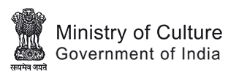

National Council of Science Museums
Ministry of Culture, Govt. of India
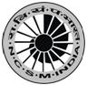
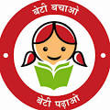
33, Block-GN, Sector- V, Salt Lake
Kolkata- 700091
Telephone- 033-2357-5545/9347/0850
www.ncsm.gov.in
Notice Inviting E-Tender No. I-15014/11(26)/21-22

E-Tender is invited for “Up-gradation of Bituminous Road at NCSM Premises, Salt Lake, Kolkata- 700091”.

Please visit website http://eprocure.gov.in/eprocure/app and search with Tender Id: 2021_NCSM_655947_1 for details & online tendering.

Tenders may be submitted between 04.11.2021 and 22.11.2021.

